LSE Data Analytics Career Accelerator Technical Report
Background
This project was an exercise in using predictive analytics and machine learning modelling to better understand patterns and trends within the Turtle Reviews data.
I focused on loyalty points and how other customer metrics related to and with such points.
I wanted to address six main areas of interest in my analysis:
Q1) Possible linear relationships between age, remuneration, and spending score regarding loyalty point accumulation?
Q2) How well can decision trees be used to understand loyalty point accumulation?
Q3) Can k-means clustering aid in understanding trends within remuneration and spending score?
Q4) Can multiple linear regression tell us anything about the relationship between remuneration, spending score and loyalty points?
Q5) How is a logistic regression model useful in showing how likely customers are to be ‘high’ loyalty point individuals?
Q6) How can natural language-processing be used to understand customer sentiments?

Methodology
- Data source: ‘turtle_reviews.csv’.
- Data selection and analysis: The file was uploaded to Jupyter Notebook (via VSC) and RStudio., for analysis.
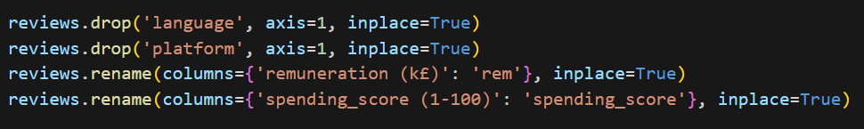
  - Further transformation of the source data was used to produce ‘reviews_clean.csv’, keeping only relevant variables:

- Data presentation/visualisation: Data presentation was conducted using libraries/packages such as matplotlib, seaborn and ggplot2.
I have explained my methodology in detail my working and thought processes within my .ipynb and .R files. My explanations were explained via markdown and in-line comments.

Q1. Possible linear relationships between age, remuneration, and spending score regarding loyalty point accumulation?

I created three separate simple linear regression models, whereby:
- Model 1:
- Model 2:
- Model 3:

Initial model creation
For each model, I made an initial split (80:20) and produced a scatterplot on the training data with a line of best fit to explore the relation between X and Y.
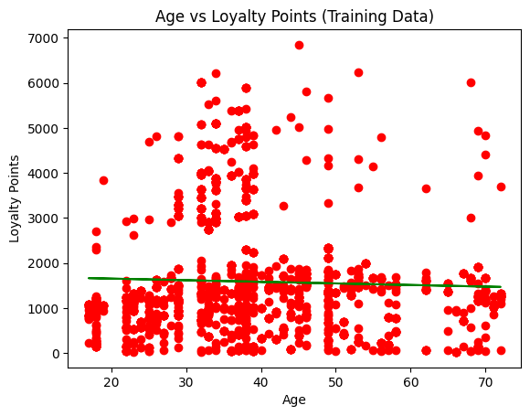

n=1600

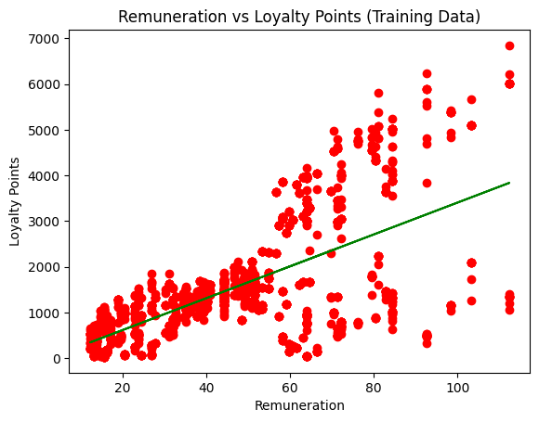

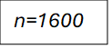
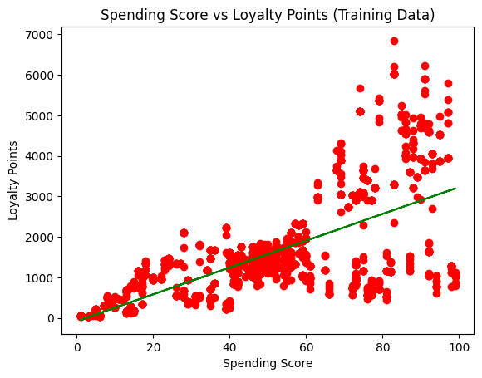

Model analysis (training set):
Model | R-Squared | Coefficient Value
Model 1 | 0.001 | -3.545
Model 2 | 0.394 | 34.899
Model 3 | 0.448 | 33.114

- Model 1 has a very low R-Squared. This indicates age explains little of the variability in loyalty points. A linear regression model does not fit the data well.
- Model 2 R-Squared value suggests a moderate fit. Remuneration captures some variability in loyalty points, but not all. The coefficient value indicates a positive linear relationship.
- Model 3 R-Squared value suggests a significantly better, yet still moderate fit. Spending score has a stronger positive correlation to loyalty point accumulation than either age or remuneration.

Evaluating the models on unseen test data
Following training my models on the training set, I tested their predictive ability on the test set.
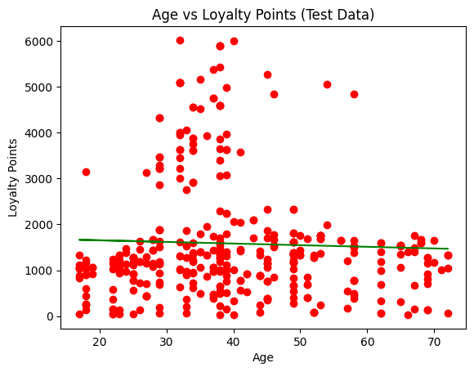

n=400

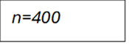
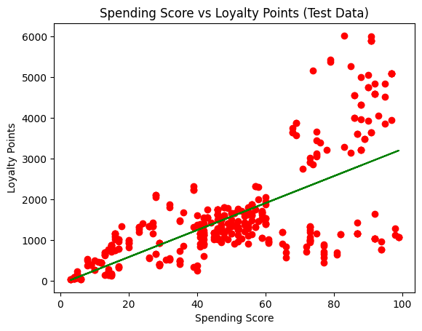
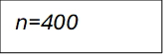
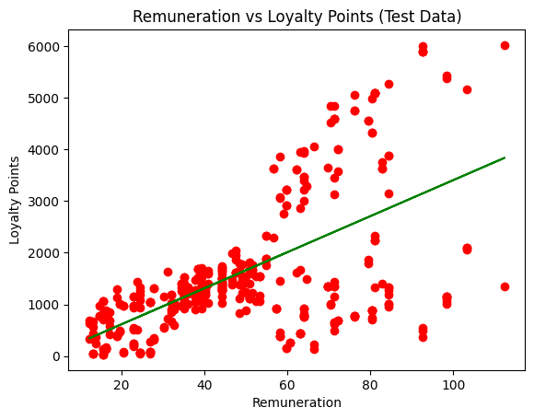
Model analysis (test set)
Model | R-Squared | MAE | M.SE | RMSE
Model 1 | 0.003 | 905.481 | 1617180.521 | 1271.684
Model 2 | 0.318 | 748.464 | 1106063.543 | 1051.696
Model 3 | 0.466 | 651.696 | 865341.581 | 930.237

- Model 1 has a very low R-Squared, and very low scores on prediction metrics, indicating significant differences between predicted and actual values. Model 1 performs poorly and does not capture any real trends/patterns between X and Y.
- Model 2 has an R-Squared which indicates a moderate fit on unseen data, however, prediction metrics indicate significant prediction error.
- Model 3 performs better than Models 1 and 2, however, there is still discrepancy between predicted and actual Y values.
My deduction from this was that to build improved simple linear regression models for each X, data wrangling/transformation was necessary.

Exploring the variables
Loyalty point distribution
The first step in achieving this was to explore the data of the variables used.
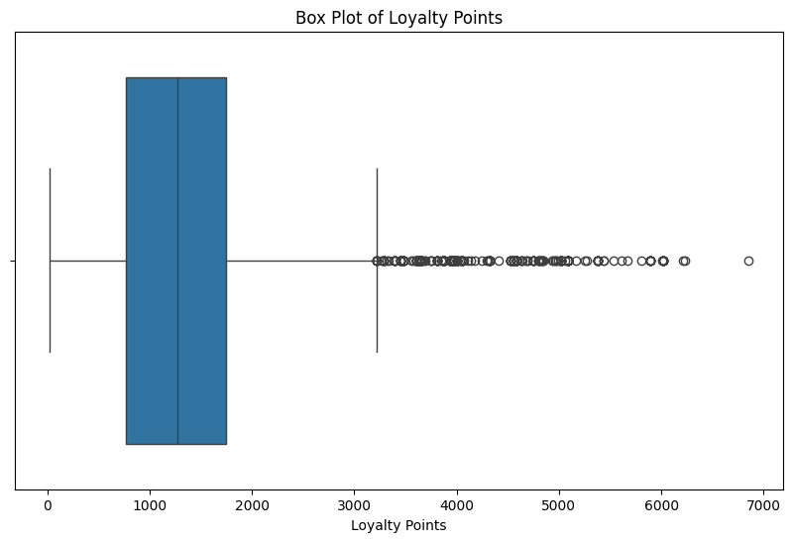
n=2000
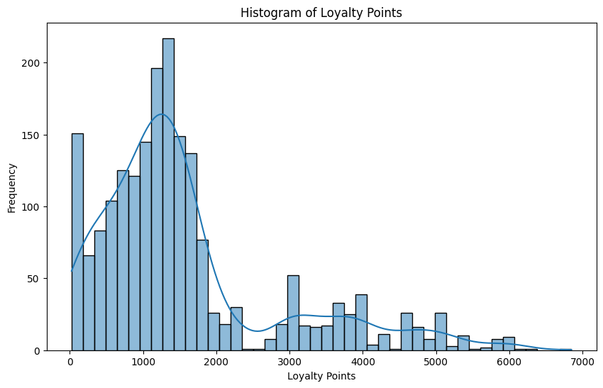
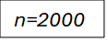
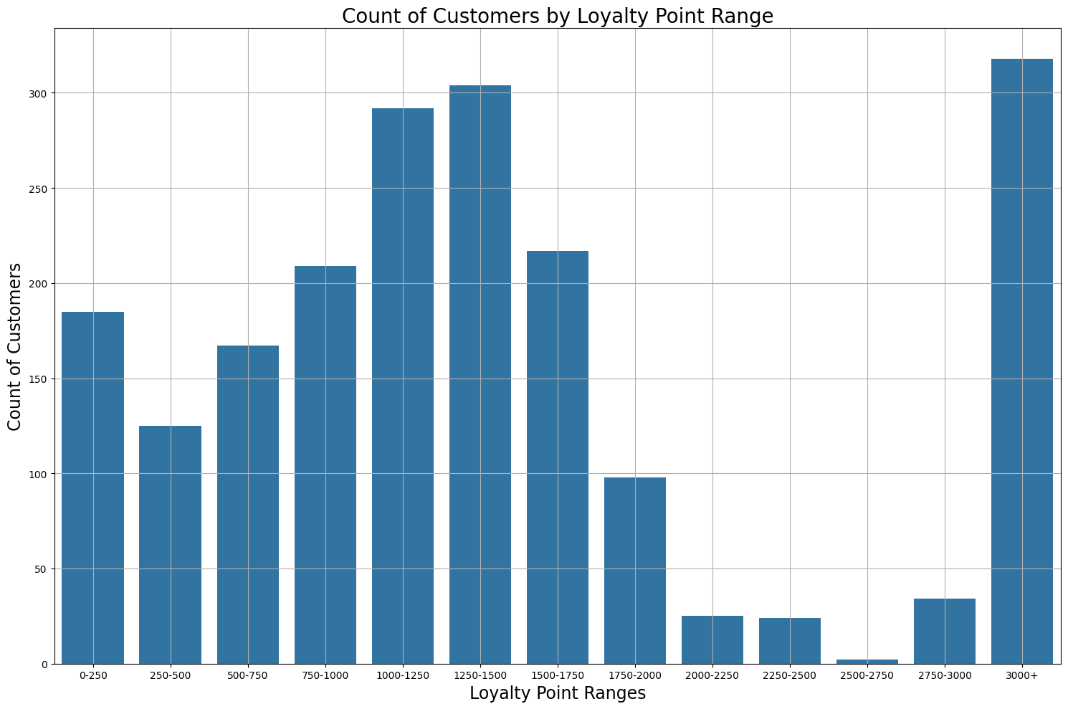
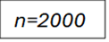
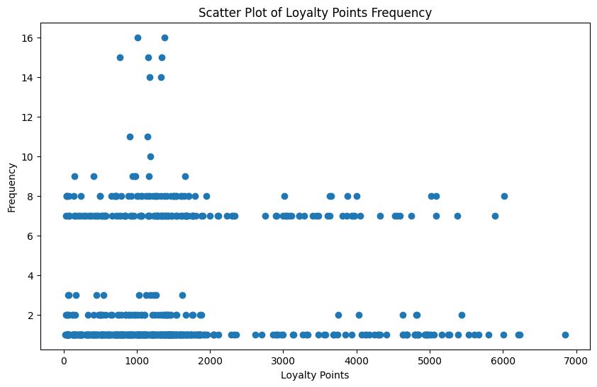
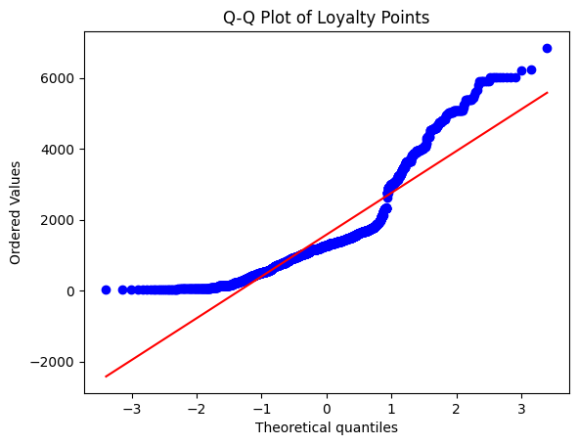

- We see greatly varied and unequal distribution of loyalty point values within the dataset.
- Most customers have loyalty points in the 0-2000 range, however, a significant contingent have above 3000, with relatively few in the 2000-3000 range. It may be suggested that two separate populations of loyalty point earners are present.
- The Q-Q Plot right tail indicates extreme outliers. Excess kurtosis produces such heavy right tails. However, the left tail suggests a normal distribution.

I employed a Shapiro-Wilk Test, which showed a p-value=1.243e-40, which also concludes loyalty point values are abnormally distributed.

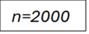
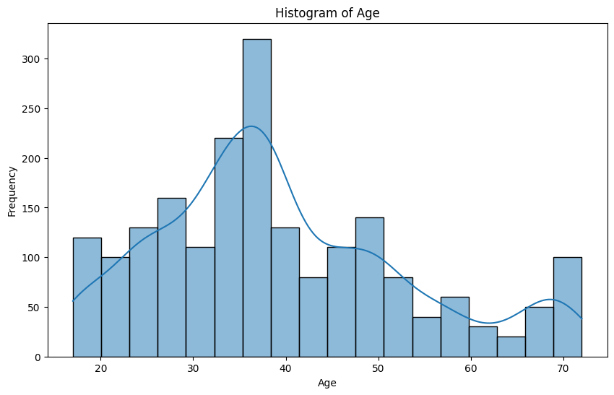
Age distribution
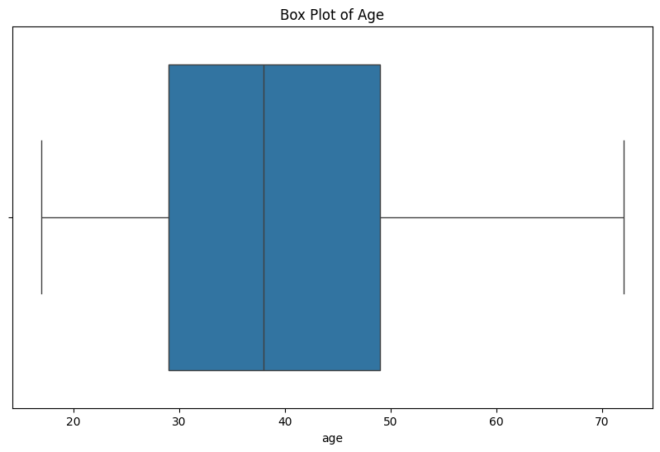

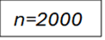
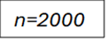
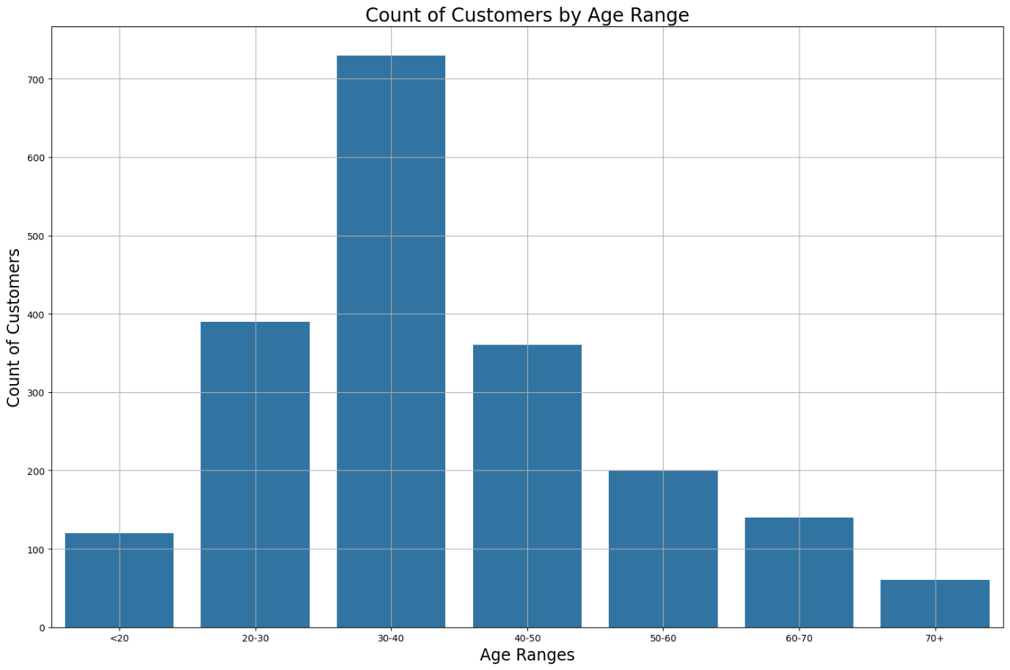
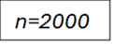
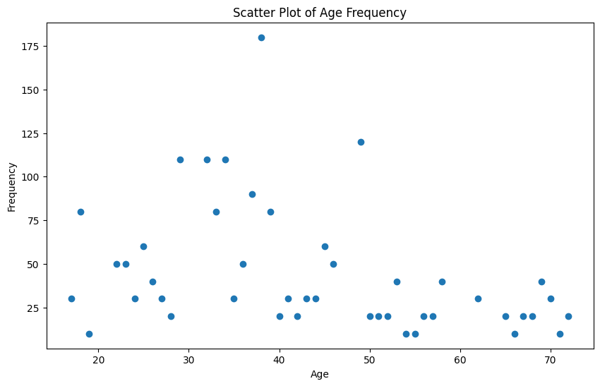

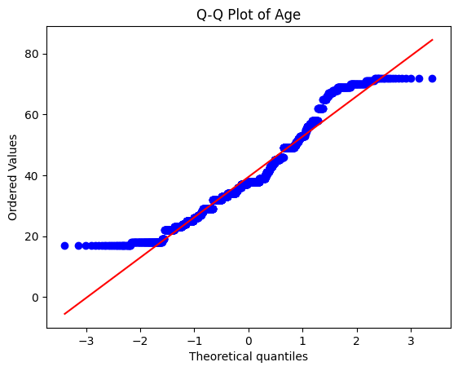

- Age has a more normal distribution than loyalty points, showing a slight negative skew.
- However, heavy right tails indicate a significant number of elderly customers (outliers).
Shapiro-Wilk Test p-value=5.394e-25 indicated a greater normality of distribution than loyalty points, while still abnormal, however.

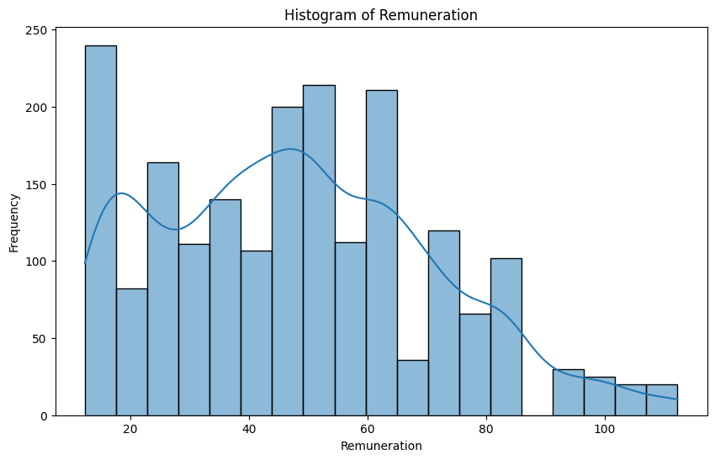
Remuneration distribution

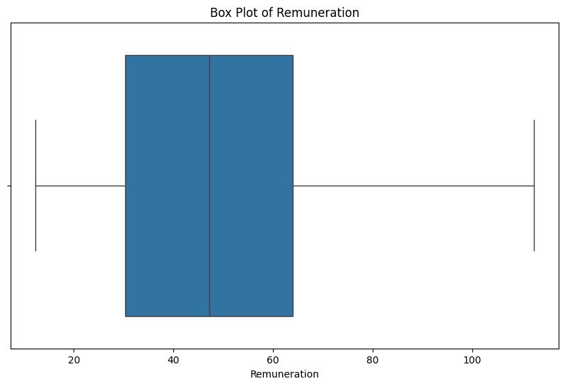

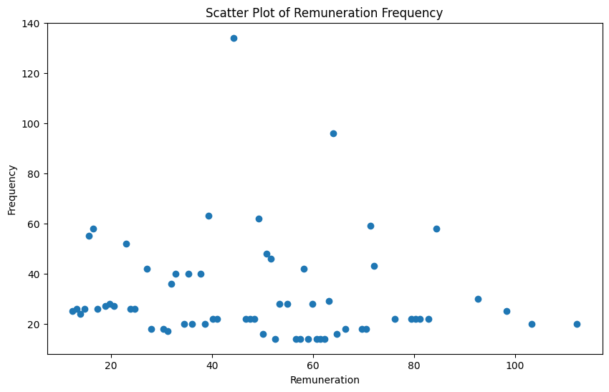

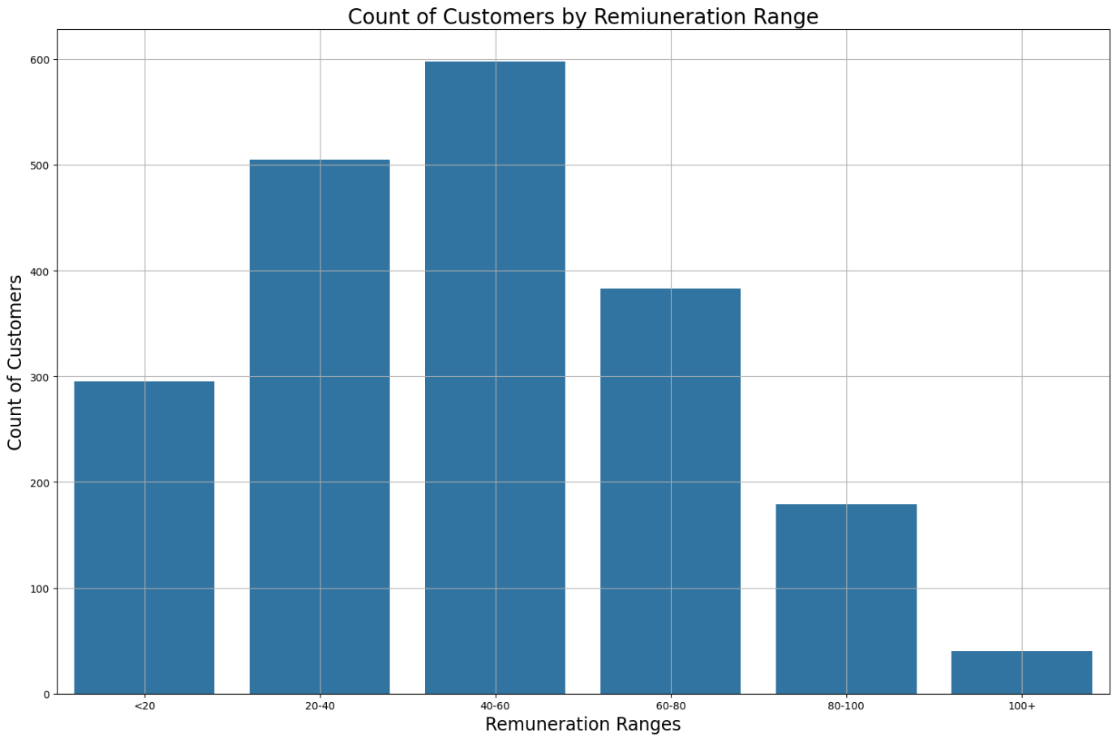
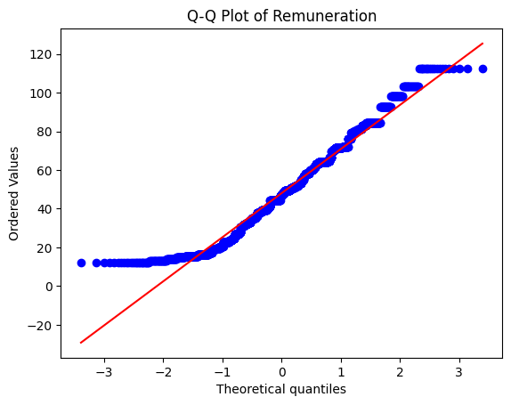
- Remuneration appears to be relatively normally distributed with no extreme outliers. The most popular range of customer remuneration is £40k-£60k.
- Distribution shows a slight negative skew.
- Q-Q Plot has a left tail lighter than normal distribution, indicating negative skew. Upper tail suggests the presence of outliers (>£100k). Boxplot corroborates this.
Shapiro-Wilk Test p-value=8.837e-21 indicates abnormal distribution of data, though not as severe as age or loyalty points.

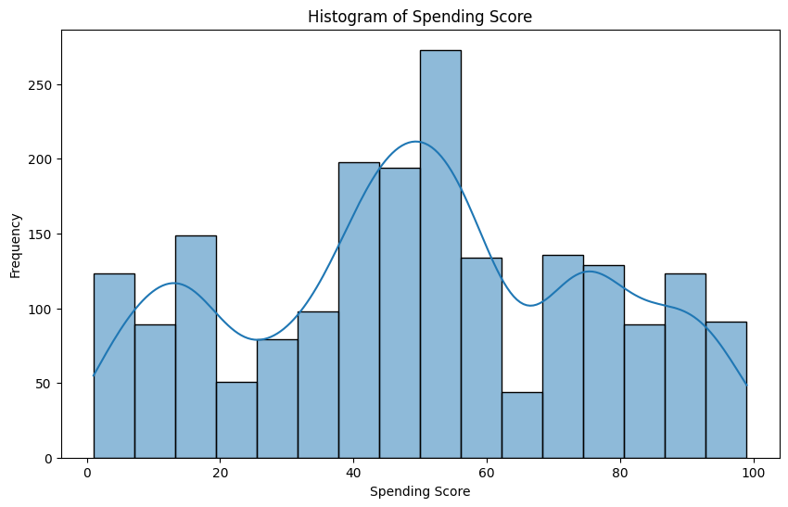
Spending Score distribution

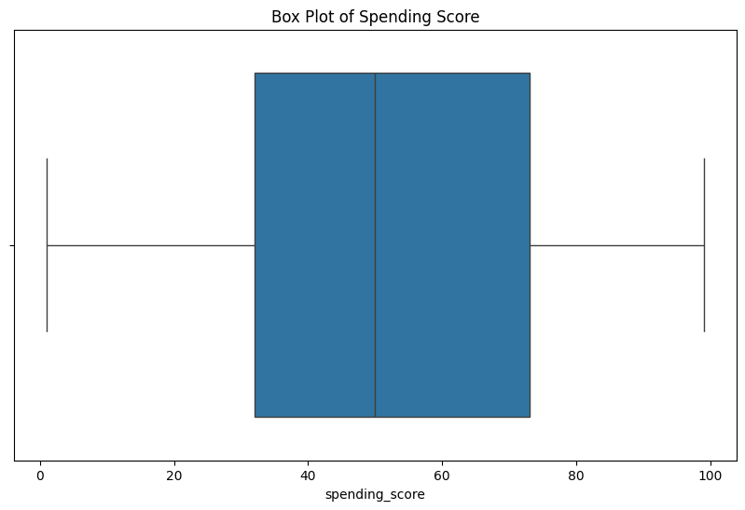

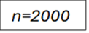
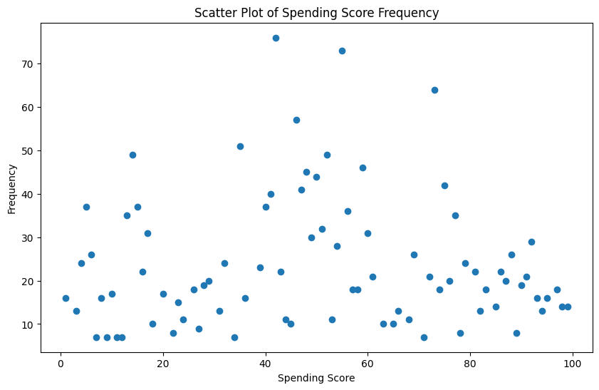
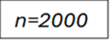

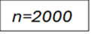
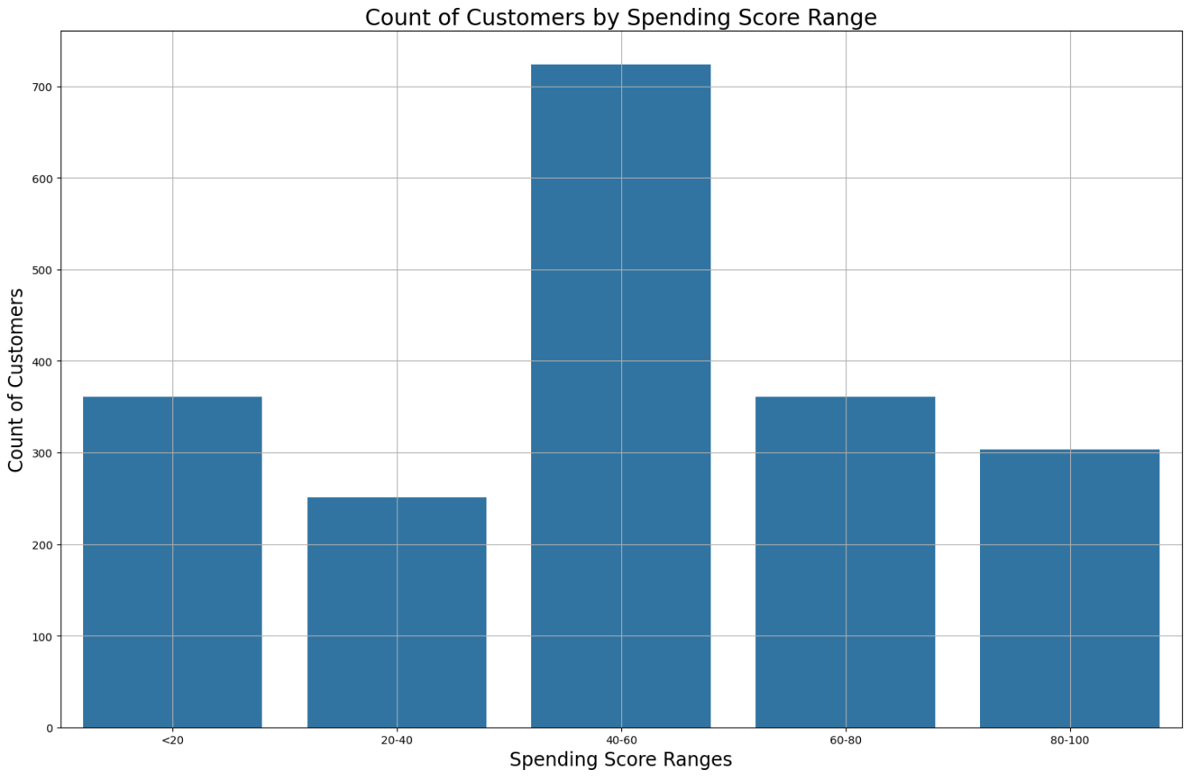

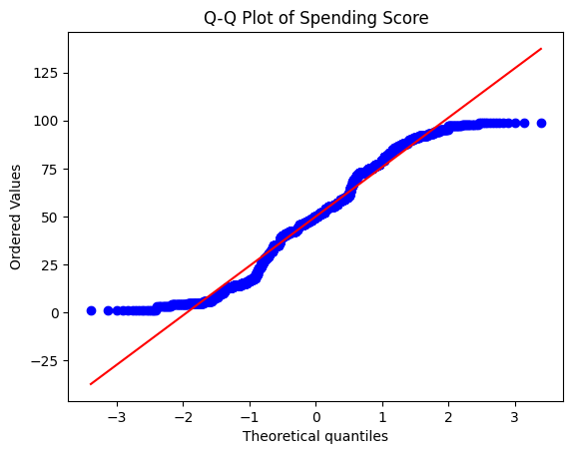

- Q-Q Plot indicates presence of outliers at extremes. Middle range of spending score values however align with normal distribution.
Shapiro-Wilk Test p-value=1.453e-20 indicates greater normality of distribution than all other variables, however, an abnormal distribution, nonetheless.

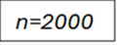
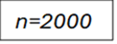
Scatterplots of loyalty points and predictor variables
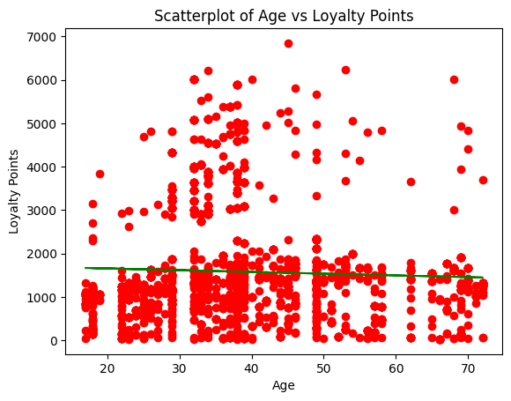

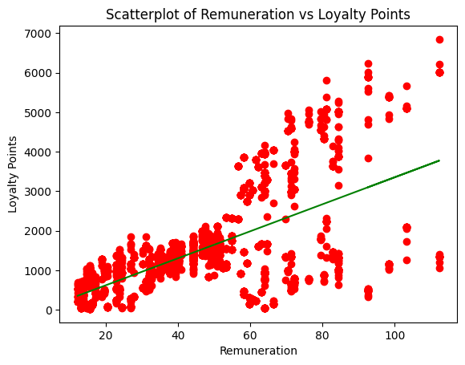

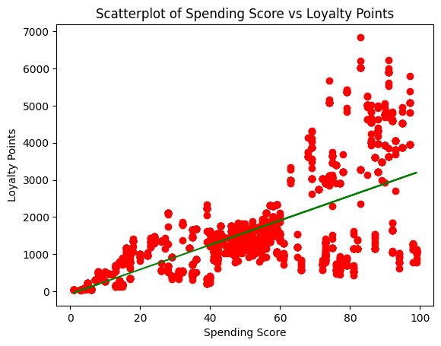

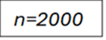

Scatterplot analysis:
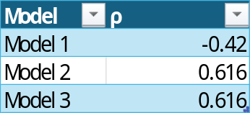

- Model 1 ρ indicates a weak negative linear relationship between age and loyalty points.
- ρ of Model 2 and Model 3 indicate a positive linear relationship. A linear regression model is suitable for capturing the relationships between loyalty points and remuneration, and spending score.

Model 1 (v2)
I recreated my simple regression model in Model 1 but accounted for loyalty point outliers using the IQR method (removing outliers outside the upper and lower bounds). I employed this method due to the highly skewed distribution of loyalty point data.

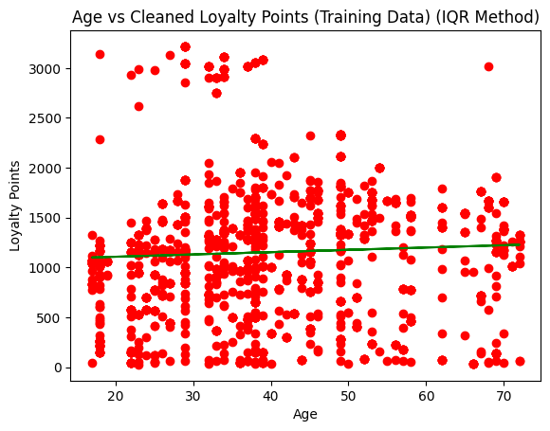
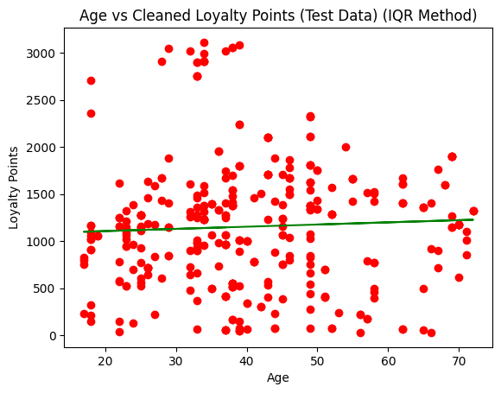
n=345
n=1387

Prediction Metrics (test set):

- Model 1(v2) fared with better prediction metrics, indicating a better predictive accuracy of the model, than when raw data was used.
- R-Squared is negative, which suggests that removing such a large contingent of the data removed patterns within said data, which decreased the R-Squared value.
- Overall, Model 1 (v2) lacks any real predictive power, and does not capture any patterns/trends between age and loyalty points.

Model 1 (v3)
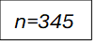
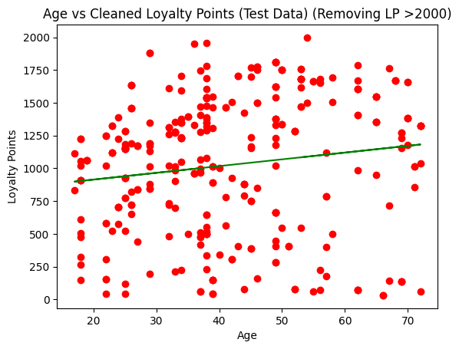
Given that I had identified two separate sub-populations within the loyalty point set, I decided to see if there were any patterns in those customers loyalty points below 2000.
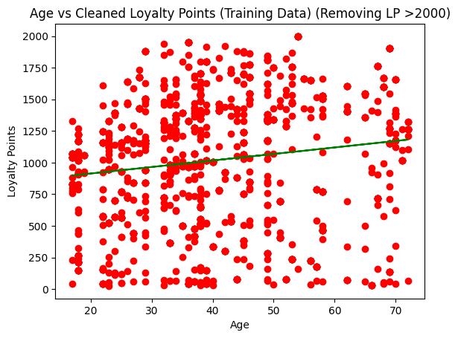
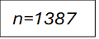

Prediction Metrics (test set):

- R-Squared is now positive, however is still very low. This model only explains 1.47% of variance in loyalty point accumulation.
- Other prediction metrics score better than Model 1 and Model 1 (v2), yet there is still significant prediction error.

I conclude that a simple linear regression model between age (X), and loyalty points (Y) is unsuitable to capture any relationship, if any, between the two.

Model 2 (v2)
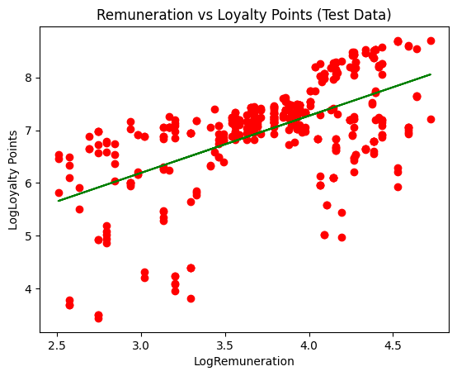
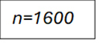
I experimented with using a log transformation on both variables, given the skewed distribution of both. My intention was to see if this would improve the predictive accuracy of my model.
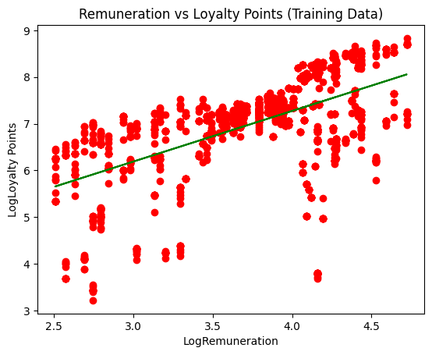

Prediction Metrics (test set):
Model | R-Squared | MAE | MSE | RMSE
Model 2 (v2) | 0.34 | 768.202 | 1165917.033 | 1051.7

- Model 2 (v3) had a marginally higher R-Squared, indicating the model captured slightly more variance in loyalty point scores.
- However, the other prediction metrics were higher, indicating less model accuracy.
- I theorise that these results are due to the wide range of loyalty point values. Upon transforming the log-transformed data back to original scale, the model is worse in its predictive abilities due to this wide range.

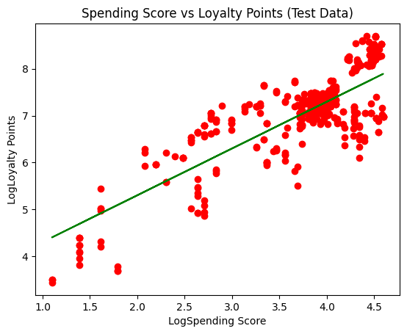
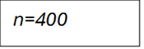
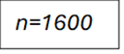
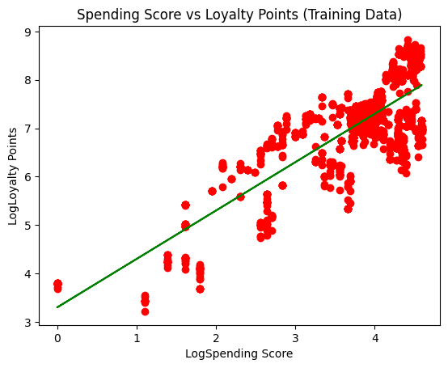
Model 3 (v2)

Prediction Metrics (test set):
Model | R-Squared | MAE | MSE | RMSE
Model 3 (v2) | 0.664 | 652.954 | 943522.424 | 971.351

- A higher R-Squared than when using raw data indicates a stronger fit on the test data.
- However, we are presented with a similar case as in Model 2 (v2), where we encounter greater prediction error.

Summary
- A simple linear regression model between age (X) and loyalty points (Y) is unsuitable. There is no real relationship between the two.
- A simple linear regression model to capture the relation between remuneration (X) and loyalty points (Y) is suitable. We see however, that the abnormal distribution of loyalty point values reduces the predictive power of a model. The same findings can be said when X is spending score.
- Spending score was most positively correlated with loyalty point accumulation, closely followed by remuneration.
- Customers can be divided into two sub-populations based on their loyalty points (>2000 and <2000 points).
Q2. How well can decision trees be used to understand loyalty point accumulation?

Building a decision tree to explore loyalty point accumulation was an exercise in balancing overfitting the model (reducing interpretability) and creating an interpretable output (increasing prediction error).
I focused on using a decision tree regressor model whereby:

Initial model creation
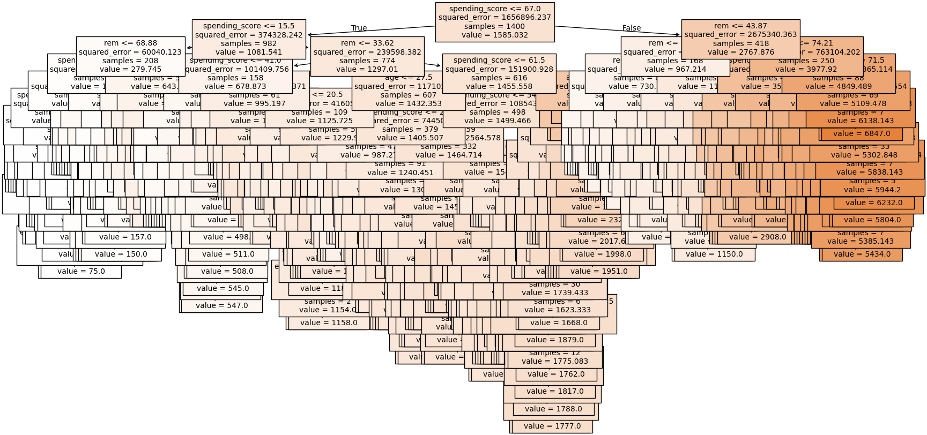

Model | MAE | MSE | RMSE
Tree 1 | 31.95 | 7599.02 | 87.17

- The model is overly complex and impractical.
- Prediction metrics indicate a moderate degree of accuracy.

Pre-pruning
I employed pre-pruning to find a prime balance between interpretability and accuracy.

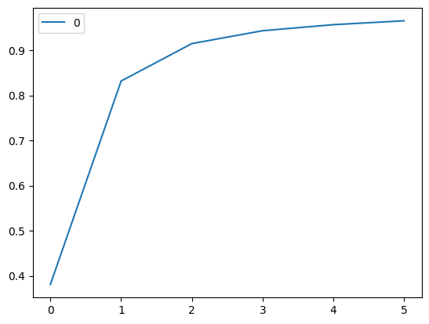
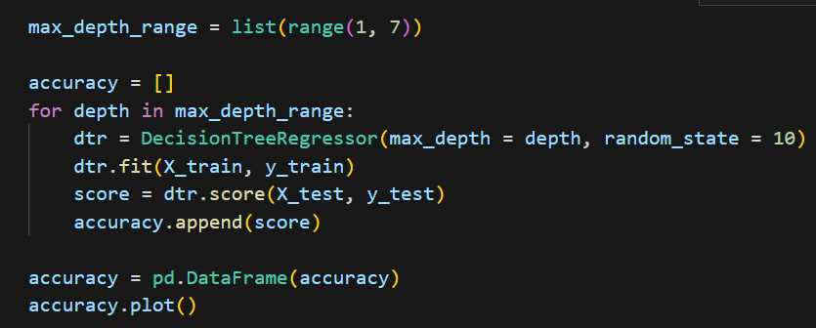
- Based on this code, the most accurate maximum depth should be 5.

I remade my tree specifying this parameter.
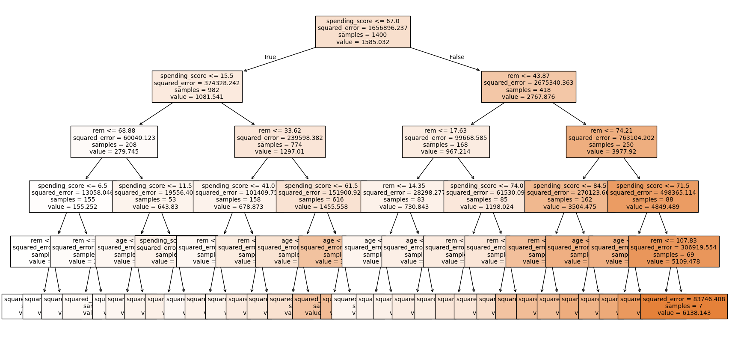
Model | MAE | MSE | RMSE
Tree 1 (v2) | 176.81 | 70121.16 | 264.8

- While the tree is now much more readable, significant prediction error persists.

In trying to find the best parameters, I utilised GridSearchCV, to find the optimum parameters.

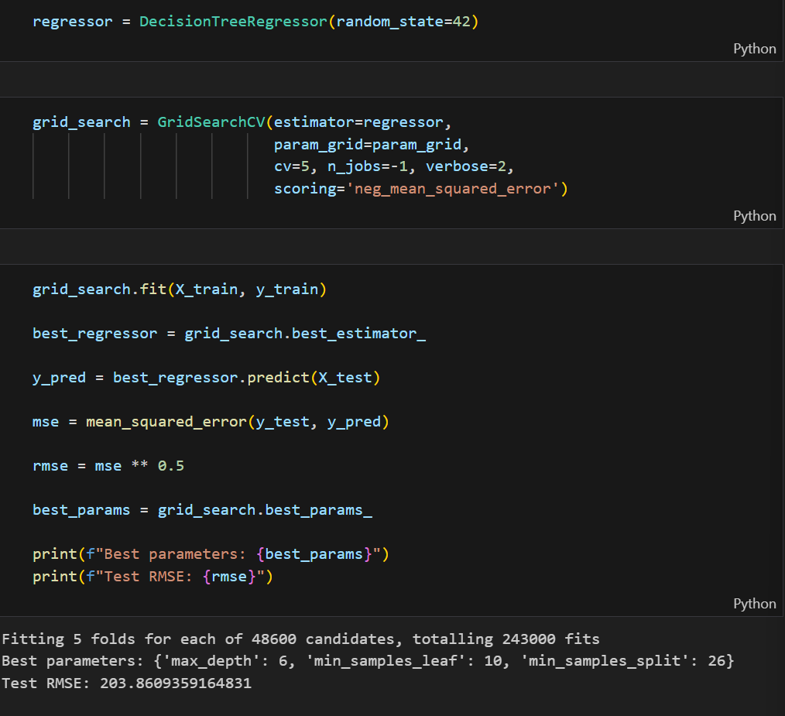

Tree with optimum parameters
Note: Due to the size of the output, view the tree here:
https://github.com/amanlang88888/amanlangprojectarchive/blob/main/decisiontreeregressoroptimal.png

Model | MAE | MSE | RMSE
Tree 1(v3) | 139.69 | 41559.28 | 203.87

- The tree is somewhat readable and gives us somewhat better prediction accuracy as opposed to Tree 1(v2).
- However, while the model is no longer heavily overfitted, it is difficult and cumbersome to interpret the model and visually intake any patterns/trends.

Feature importance
Another approach I implemented was to only use statistically significant predictor variables. I did this to reduce model complexity.

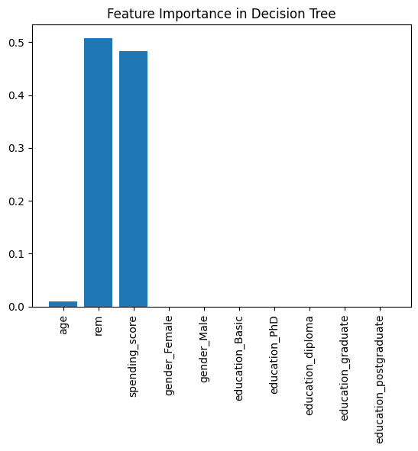

- It is evident that remuneration, spending score, and, to a much lesser extent, age are significant variables.

Combining pruning techniques
I remade my model focusing only on customers earning <2000 loyalty points and using only remuneration and spending score. I also employed GridSearchCV to find optimal parameters.
https://github.com/amanlang88888/amanlangprojectarchive/blob/main/treegoodunder2000.png
Model | MAE | MSE | RMSE
Tree 1(v4) | 119.72 | 26800.53 | 163.71

- Prediction metrics indicate significant prediction error.
- However, the model is still interpretable.
- While the prediction metrics do not indicate as good a fit as when all features were used, and no parameters were specified, the model is more readable.
- The trend shown is that generally, positive increase in both remuneration and spending score is associated with greater loyalty point accumulation.

Summary
- Remuneration and spending score are key determinants in predicting loyalty points, presenting positive correlation in both variables with respect to loyalty points.
- A decision tree regressor model can be used in the context of predicting loyalty point accumulation, however it presents drawbacks:
  - Pre-pruning reduces overfitting, while reducing accuracy.
  - The continuous nature of the variables means that insights are difficult to present.

Q3. Can k-means clustering aid in understanding trends within remuneration and spending score?

I wanted to explore if there are any correlations or groups when looking at remuneration and spending score.
Initial exploration
I wanted to see if there were any patterns with remuneration and spending score in interactions with gender. I scaled my data using Min-Max method, due to the lack of extreme outliers, and abnormal distribution.
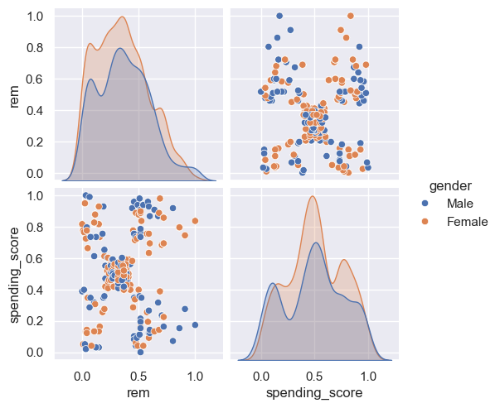
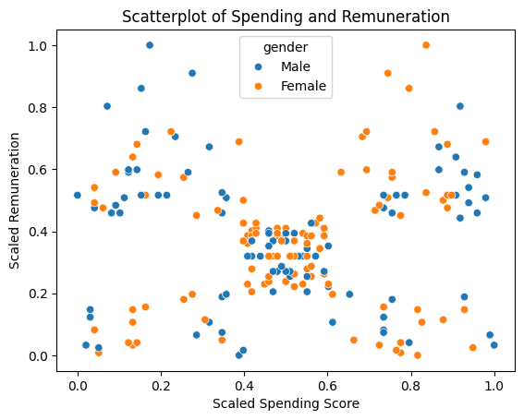
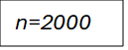
n=2000

- The scatterplot does not show us any discerning trends. The distribution of gender between remuneration and spending score appears random.
- The pairgrid however shows us that males will mirror females in remuneration and spending score values, however, their scores are significantly lower.

I was curious to see interactions with loyalty points.
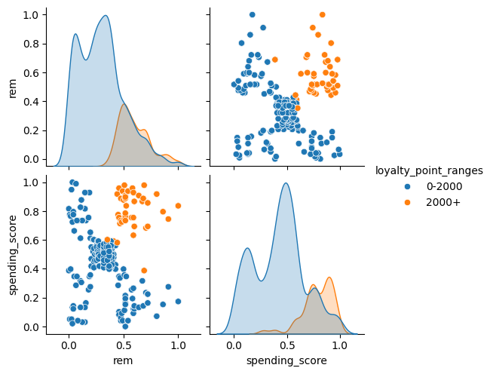
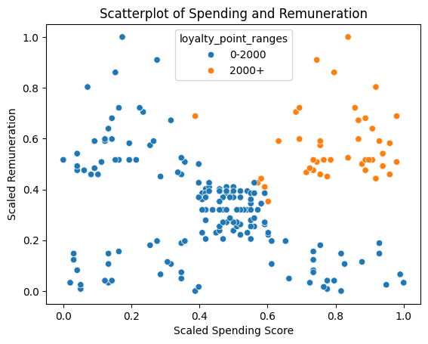
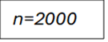

- There is a more evident trend here. High loyalty point earners (>2000 points) are associated with higher remuneration and spending scores.
- Those in the >2000 range are a distinct population from those in the 0-2000 range.

Finding the optimal number of clusters
I find the optimal number of clusters, k, to ensure meaning grouping between remuneration and spending score, whereby:

I used the Elbow Method to determine k.
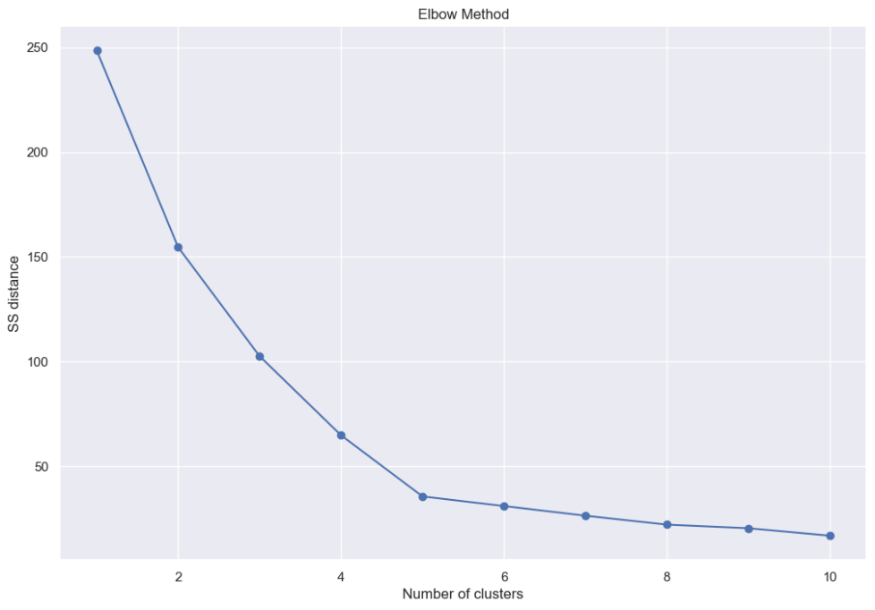
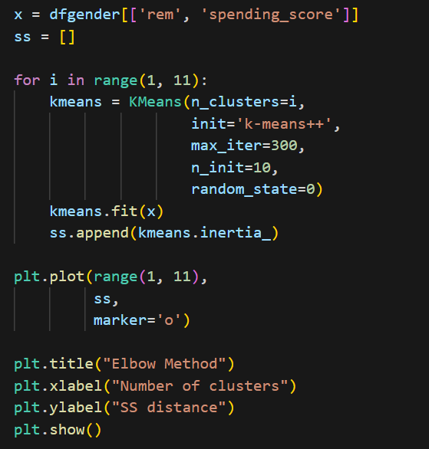

- k=5 according to this method.

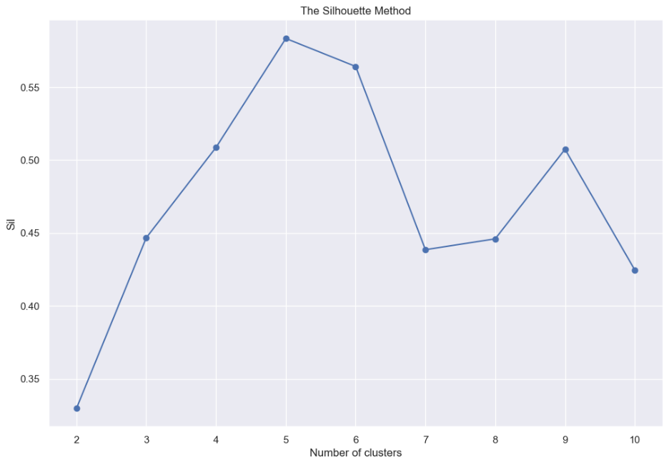
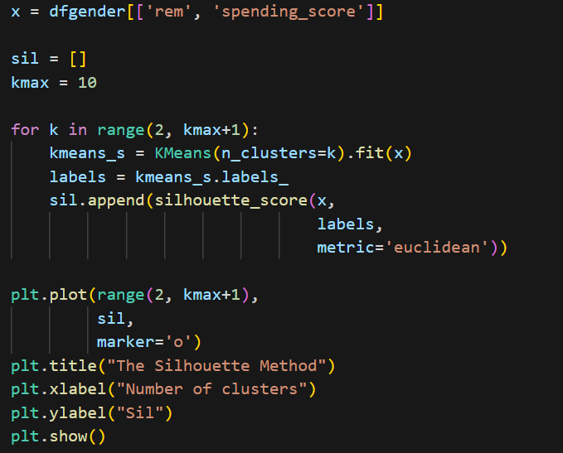
I used the Silhouette Method to find silhouette score for different k numbers.

- k=5 would garner the highest silhouette score.

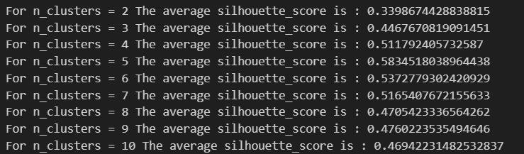
I also implemented another method, which also calculates silhouette score and coefficient, yet provides cluster visualisation for each k number.
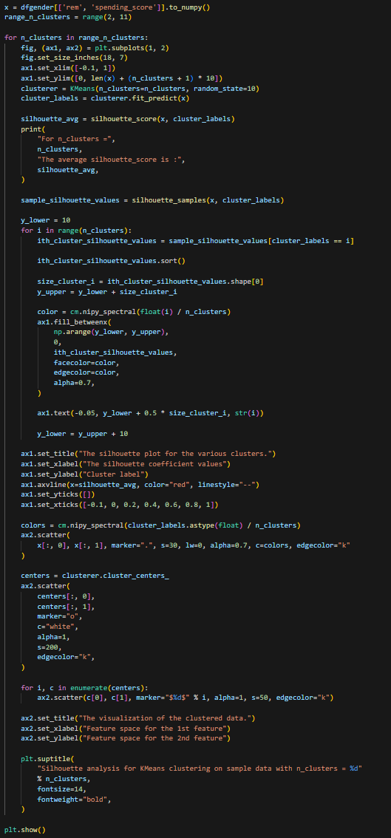

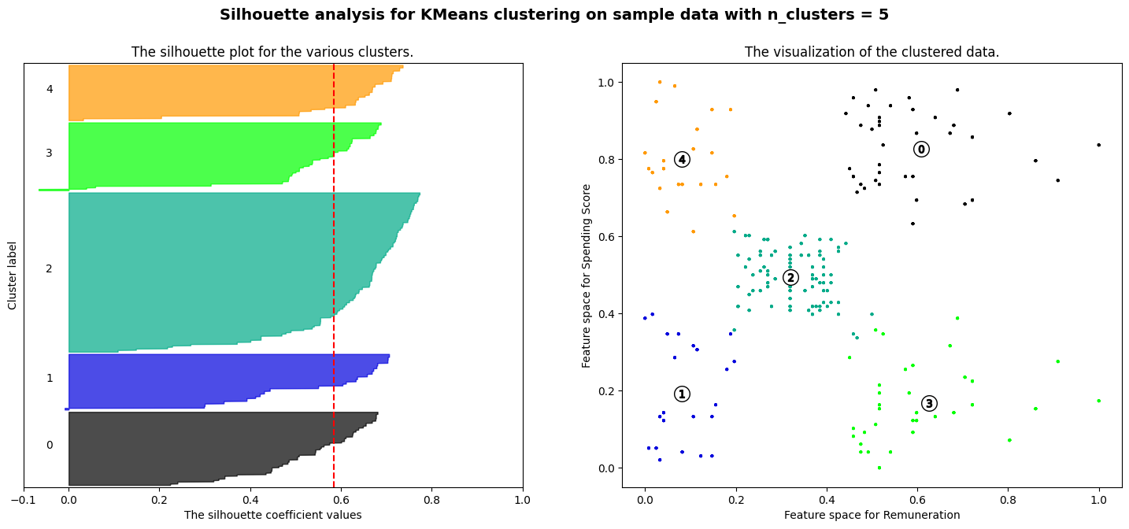
- We can confirm k=5 allows for meaningful and distinct clusters.

Visualizations
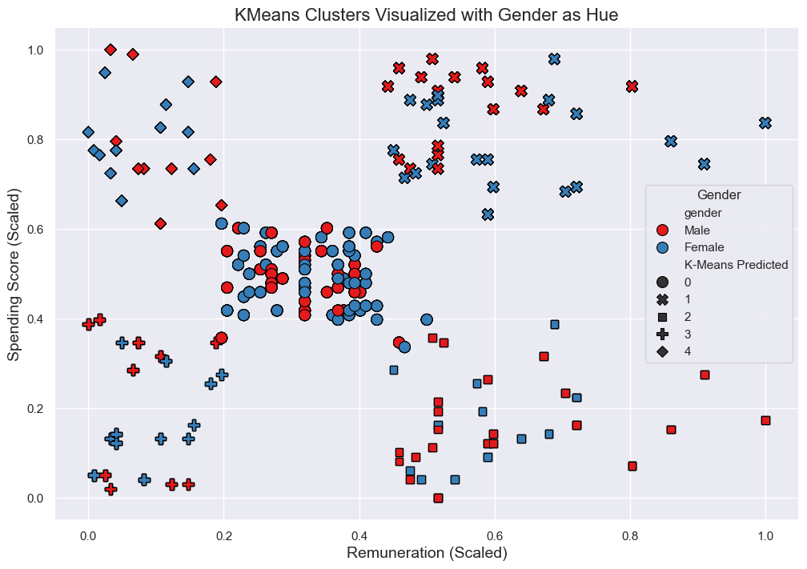
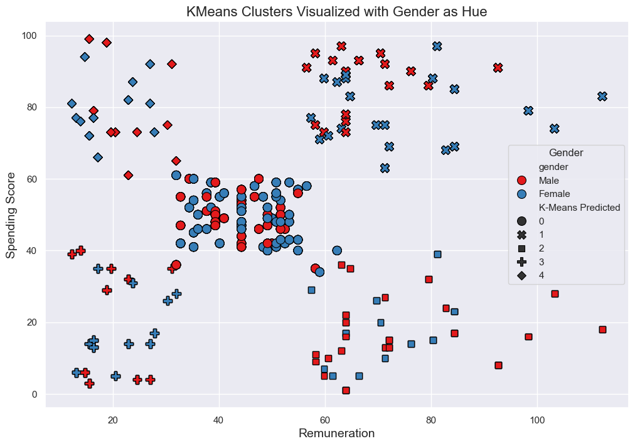
- We see that there is not much of a pattern when looking at how gender interacts with k-means predicted clusters.

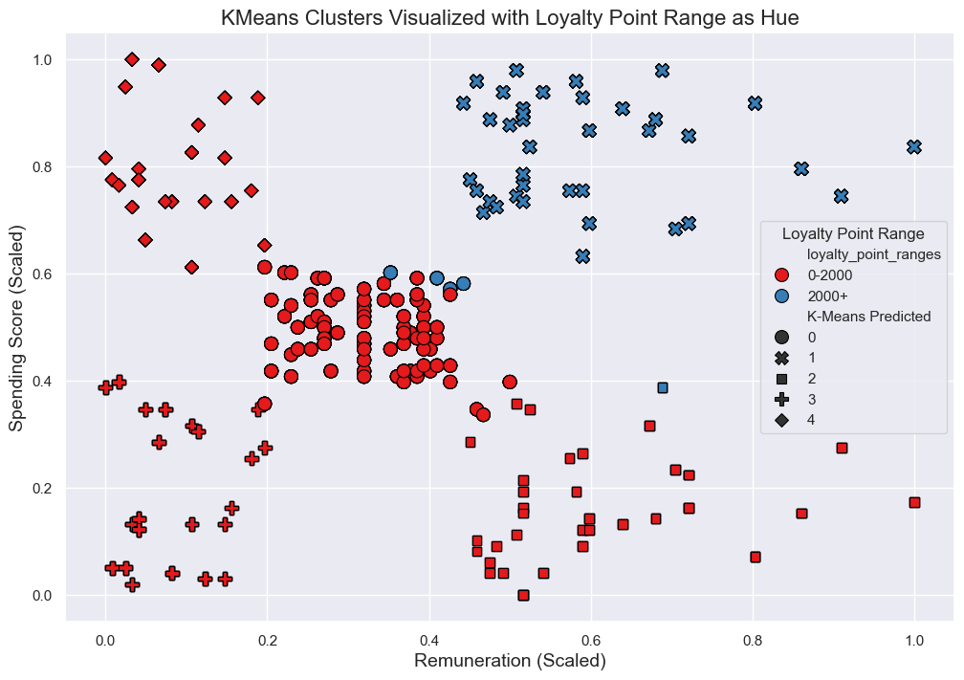

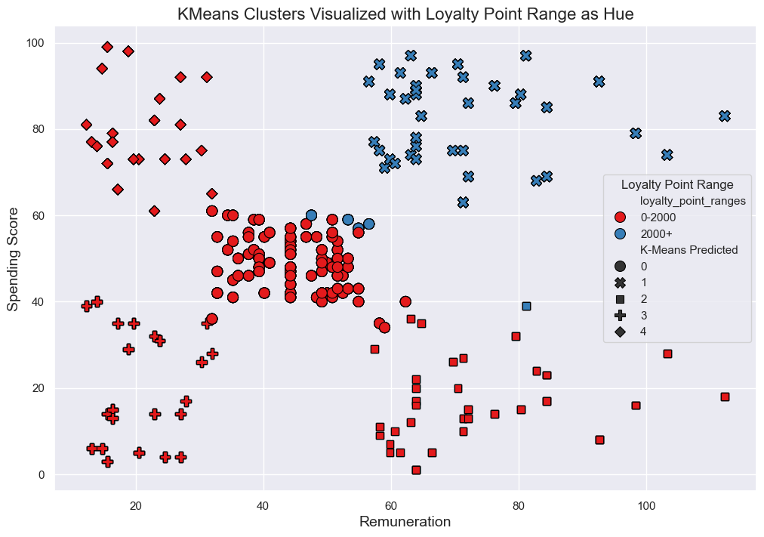
- We see one cluster is separate, and this largely is the >2000 points population, which is distinct from all other clusters. Customers in this cluster have high remuneration and spending score.

Summary
- There are five distinct groups of customers with similar remuneration and spending scores.
- There is not much of a distinct pattern of gender within these groups.
- High loyalty point earners are largely a distinct group from the rest of the population.

Q4
I decided to focus on only using remuneration and spending score as my predictor variables, being the most statistically significant in relation to loyalty points.
I created a multiple linear regression model whereby:

Initial model creation
I created an initial model using raw data.
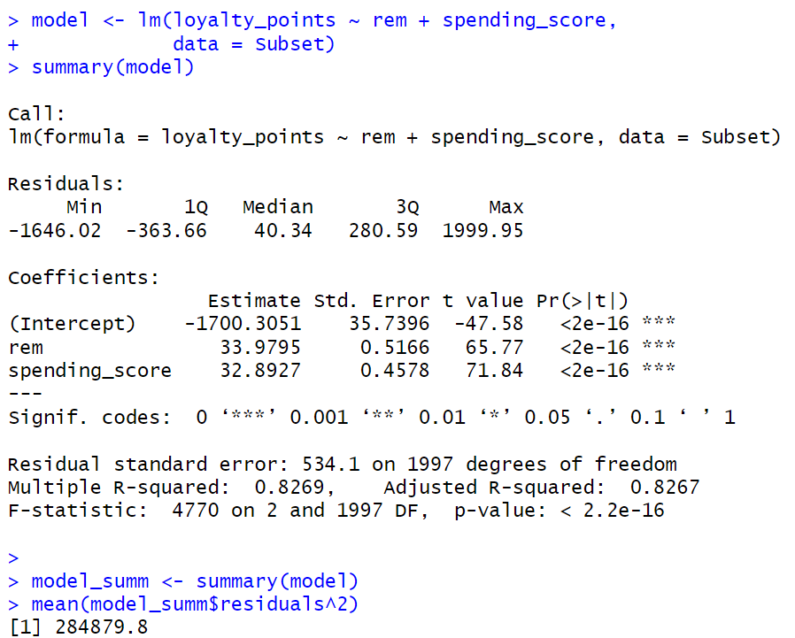
- R-Squared, F-Statistic indicates model is a strong fit on the data.
- There is a strong relationship between the outcome and predictor variables.
- However, the model is not very accurate, due to a high MSE.

Assumptions for MLR
I conducted exploratory analytics.
- Multicollinearity:
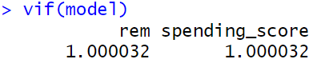
- There is low correlation between remuneration and spending score.
- Low VIF values indicate little multicollinearity.

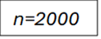
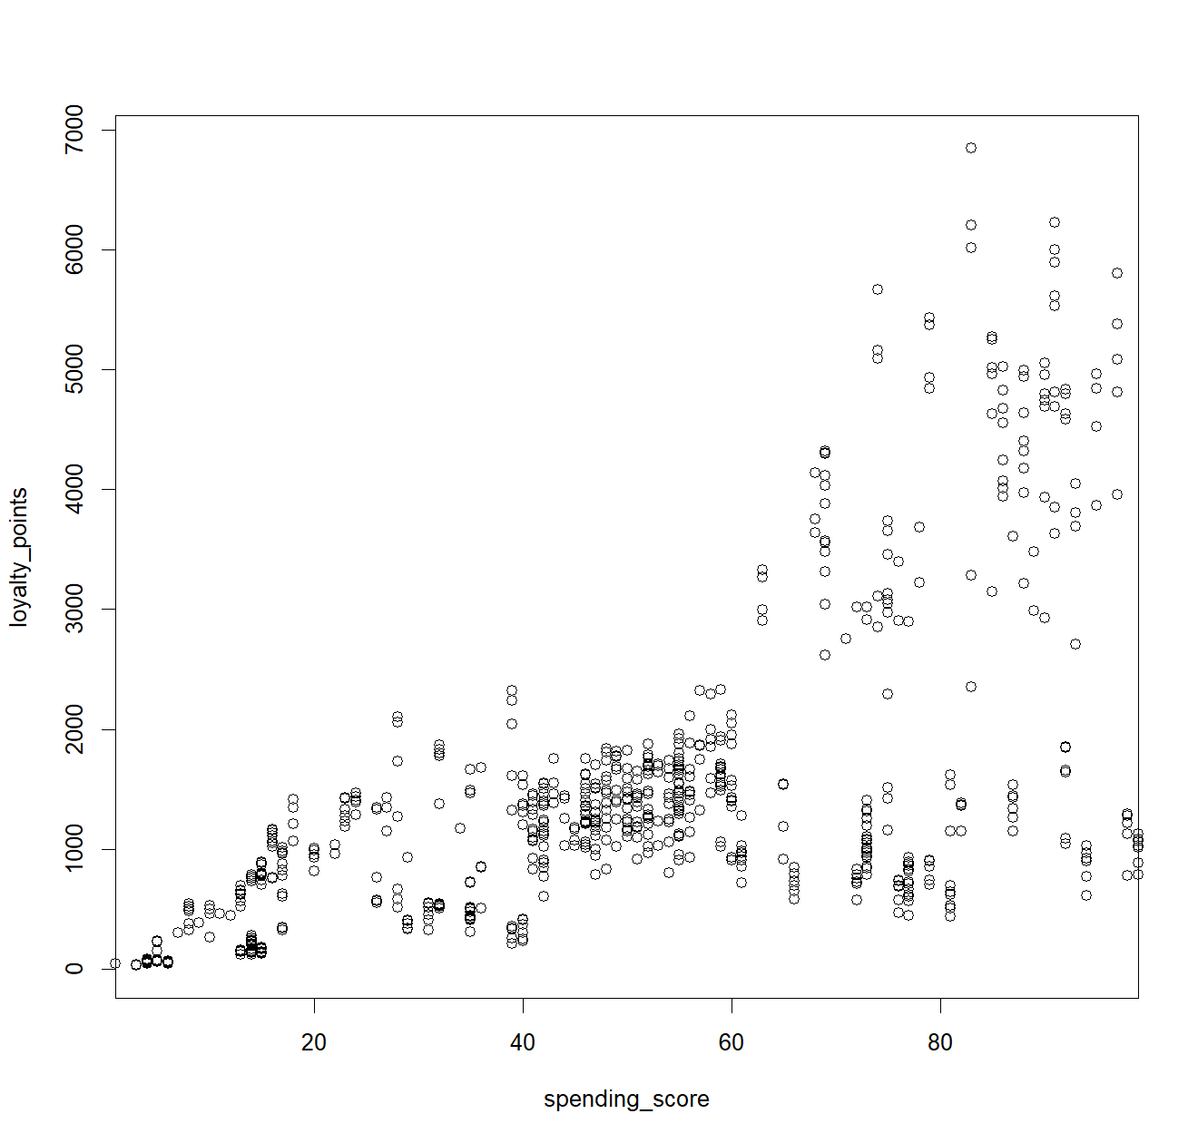
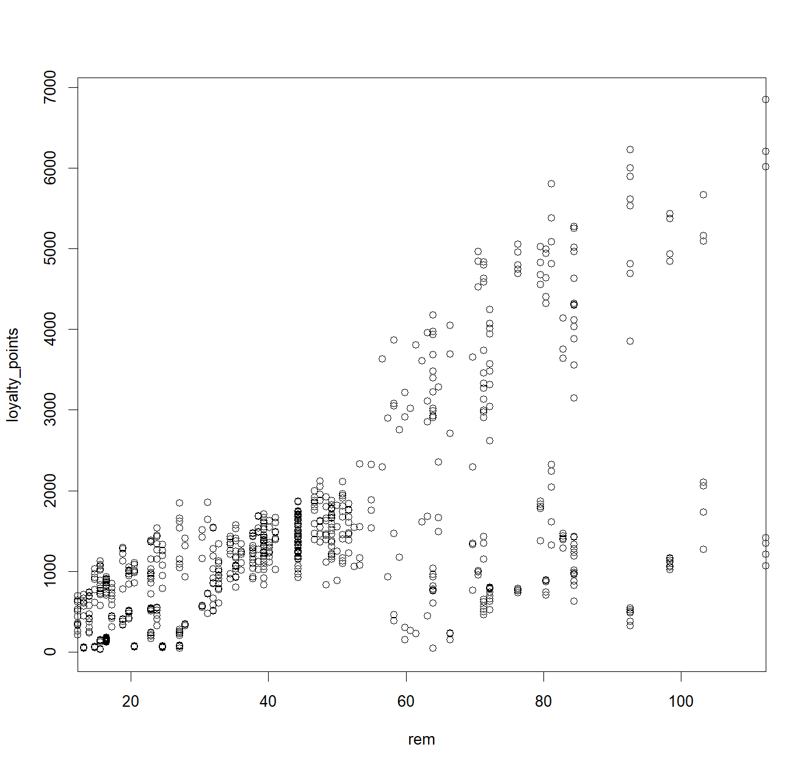
- Linearity:

- Visually, Y~X1, Y~X2 is linear.

- Independence of Residuals
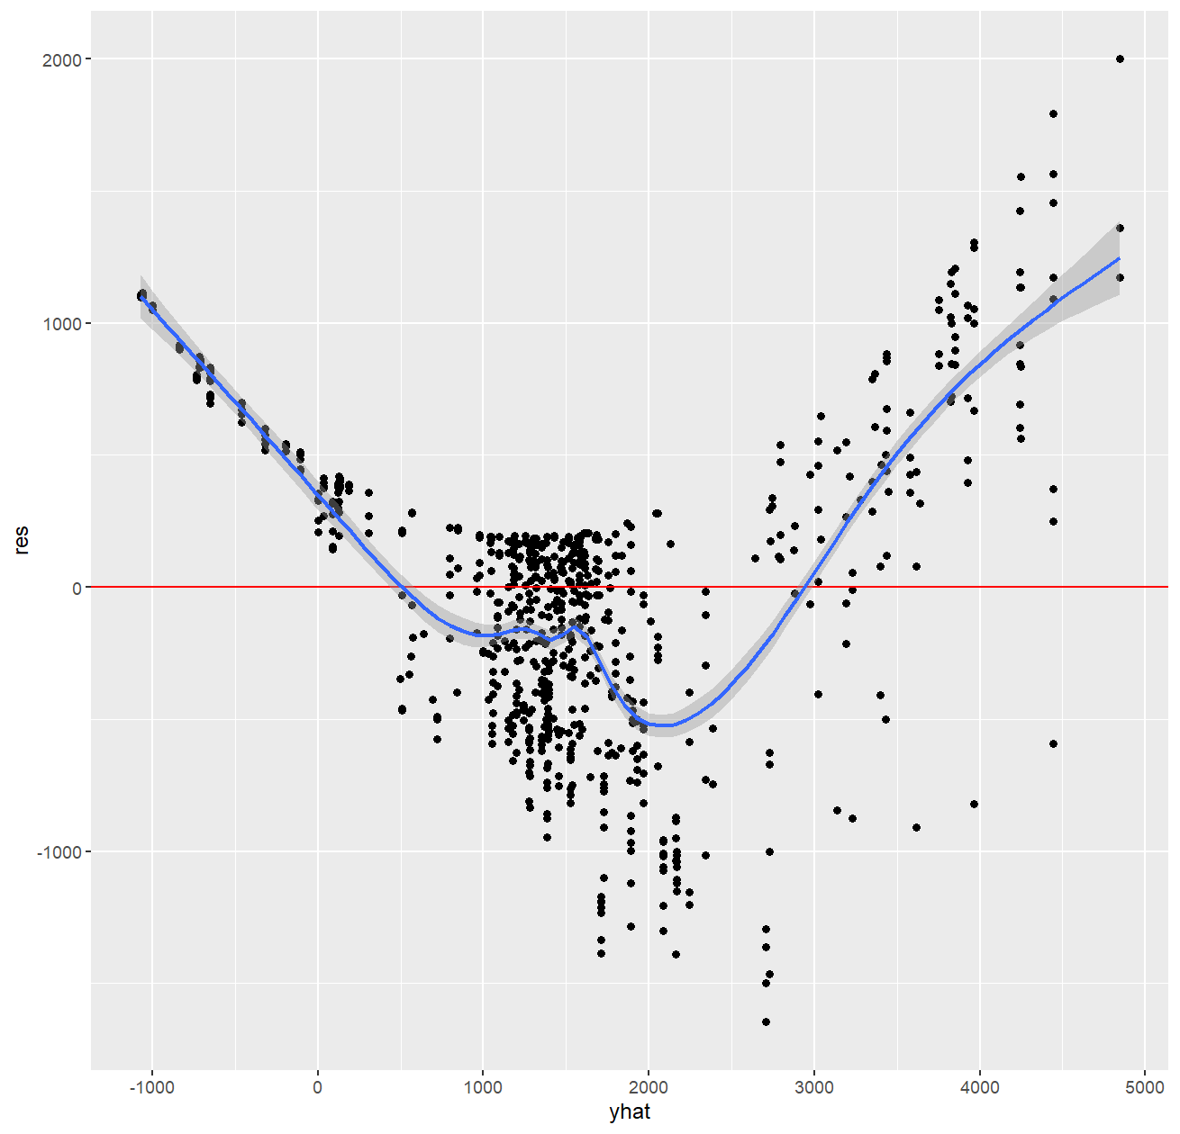

- From here, we see that our residuals do not align to predicted values.
- The curve in the plotted residuals suggest linearity is violated. This may be due to non-linear patterns in residuals.

- Normality

As previously established, loyalty point values are abnormally distributed. I check for normality of residual distribution in Y.
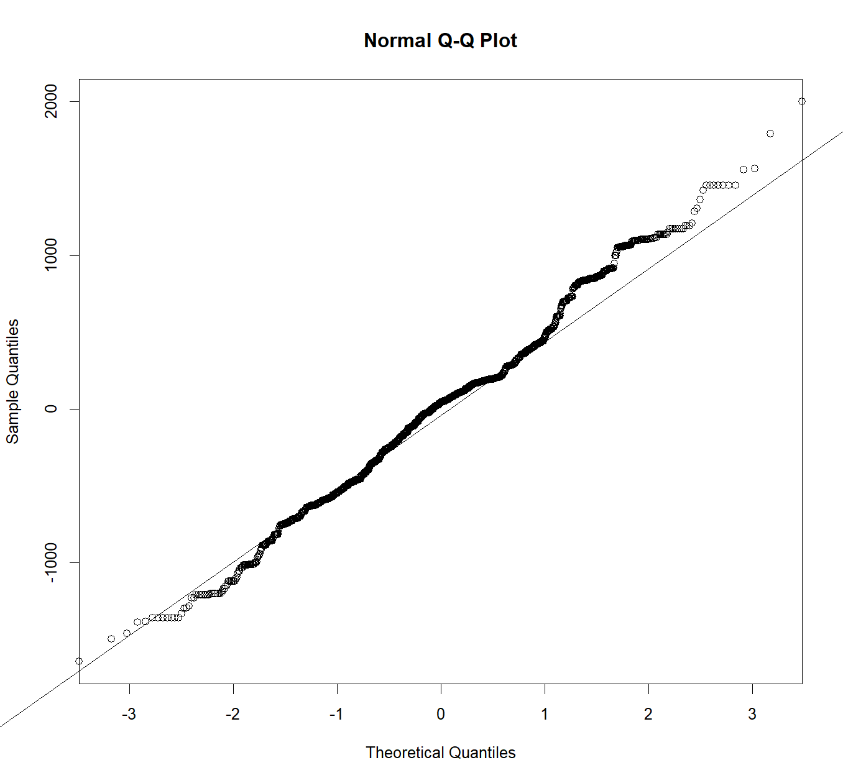
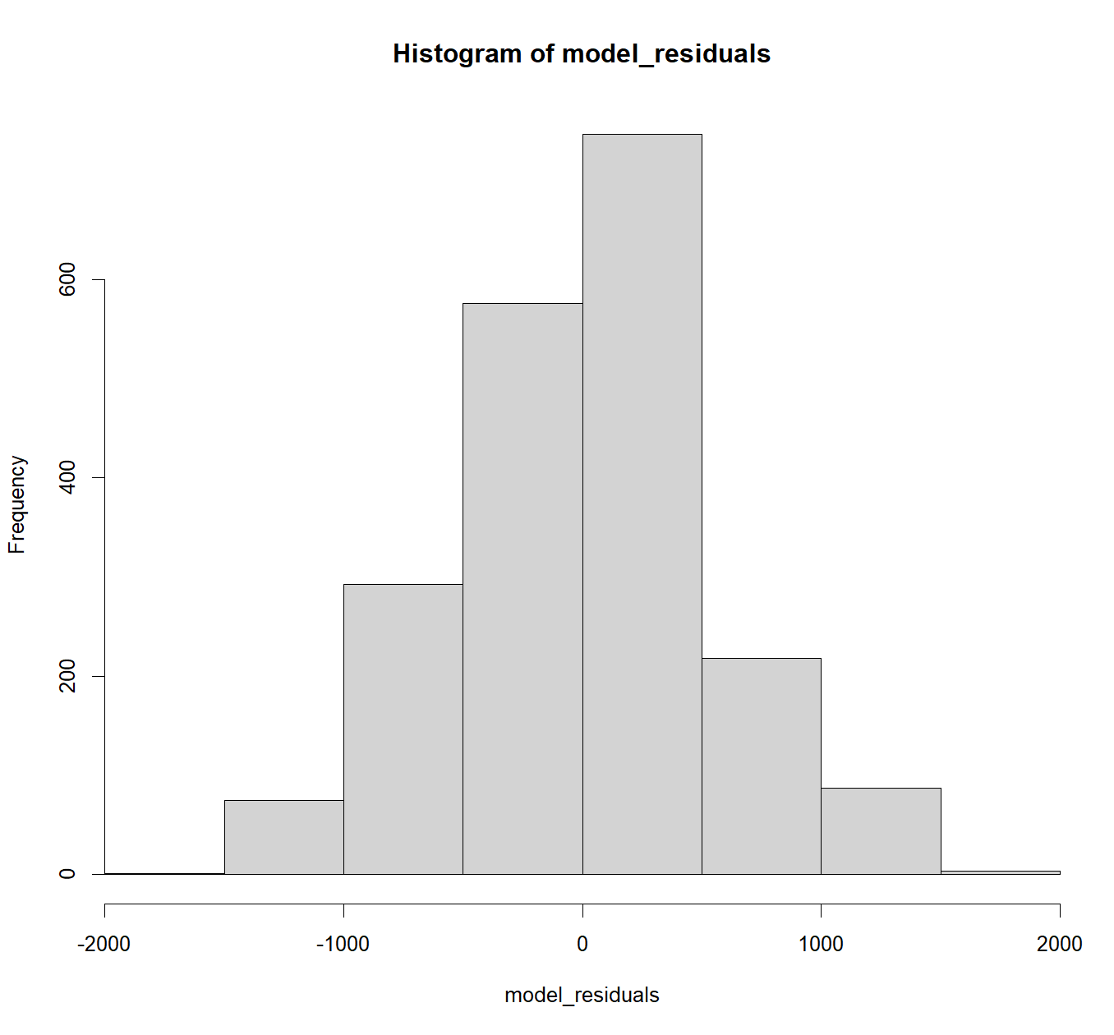
- The histogram would suggest, visually a more normal distribution of residuals.
- Q-Q Plot suggests that there are heavy outliers at the right tail.
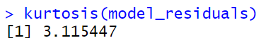
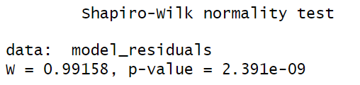
- The residuals are abnormally distributed.
- There are heavy right tails.
- The residuals are asymmetrically distributed.

- Homoscedasticity
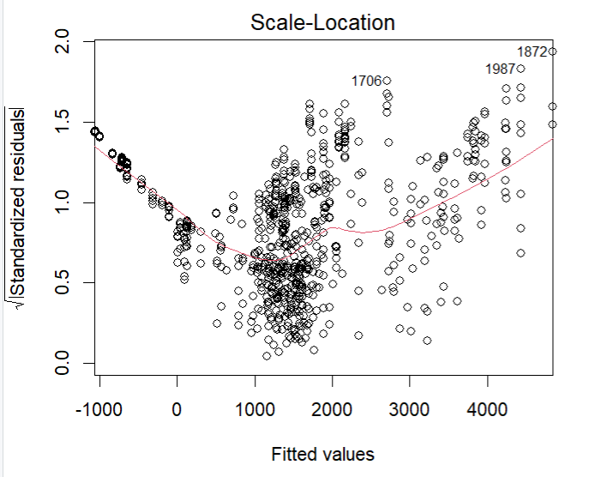
- Variance of standardised residuals is not consistent across the range of fitted values. This indicates heteroscedasticity.

Polynomial regression
Due to issues with abnormal residual distribution, heteroscedasticity, and non-linearity of residuals, I implement polynomial regression with the intention of capturing possible non-linear patterns, whereby:
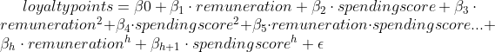

I want to find the optimal degree, h, to strike a balance between model flexibility in capturing complex patterns, whilst preventing overfitting. To do this, I performed k-fold cross validation, and calculated MSE for each h value. I set k=10, in consideration of computational efficiency, and as a bias-variance balance.
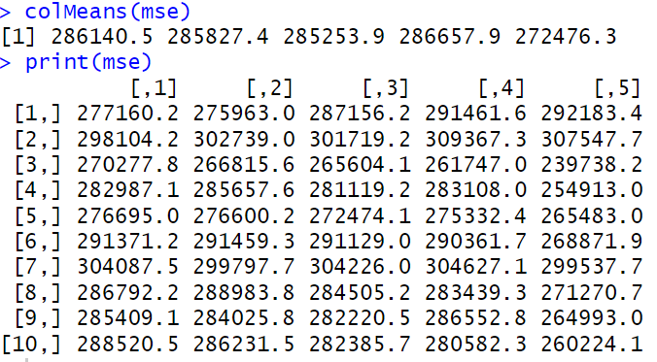
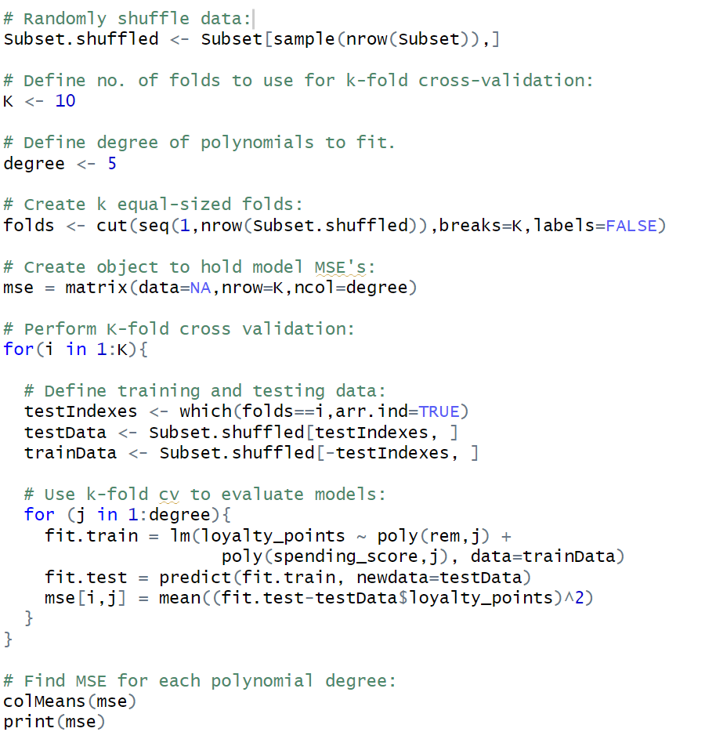

- h=5 produced the lowest MSE, indicating the optimal h value.

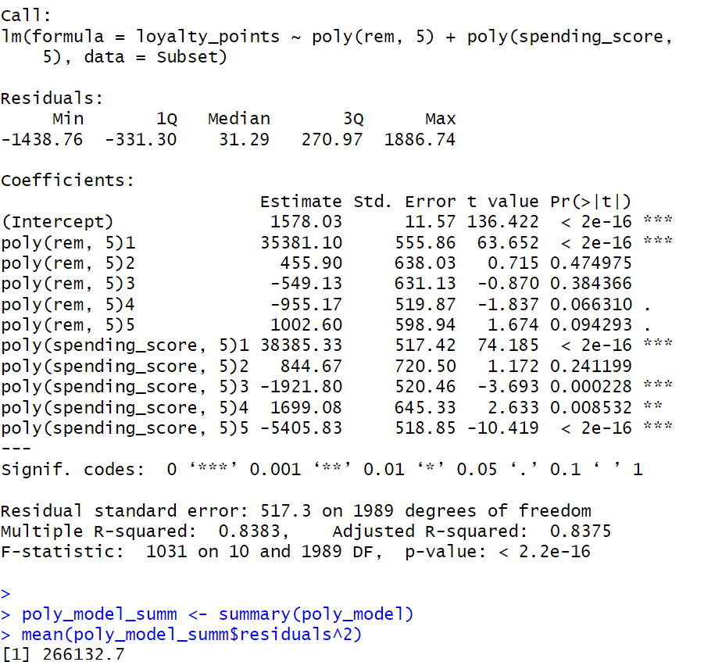

- R-Squared value indicates that the polynomial regression model explains a large portion of variance in loyalty points.
- MSE is high, indicating significant prediction error. However, this is more accurate than when uncleaned data was used.

Polynomial regression using significant terms
I remade my model using significant polynomial terms:
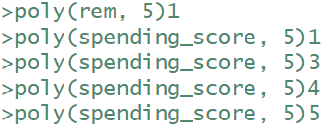
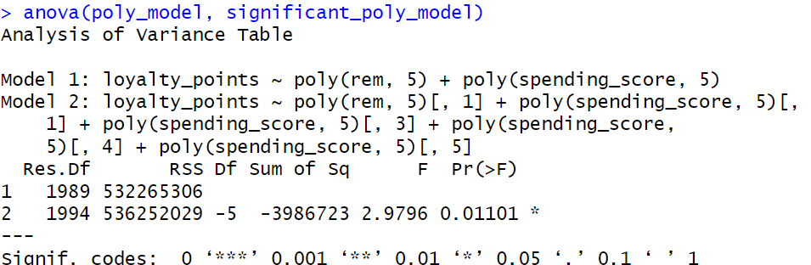
- However, in comparison to the original polynomial regression model, a significant degradation in model fit occurred.
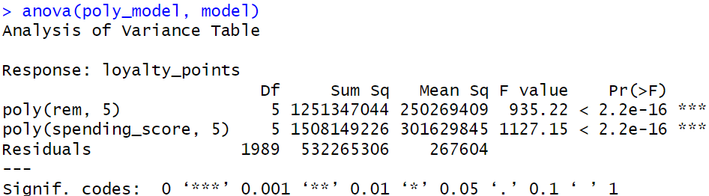

- The polynomial regression model produced a significant improvement in fit compared to the original MLR model.

Independence of Residuals
A persistent problem persisted still in the polynomial regression model.
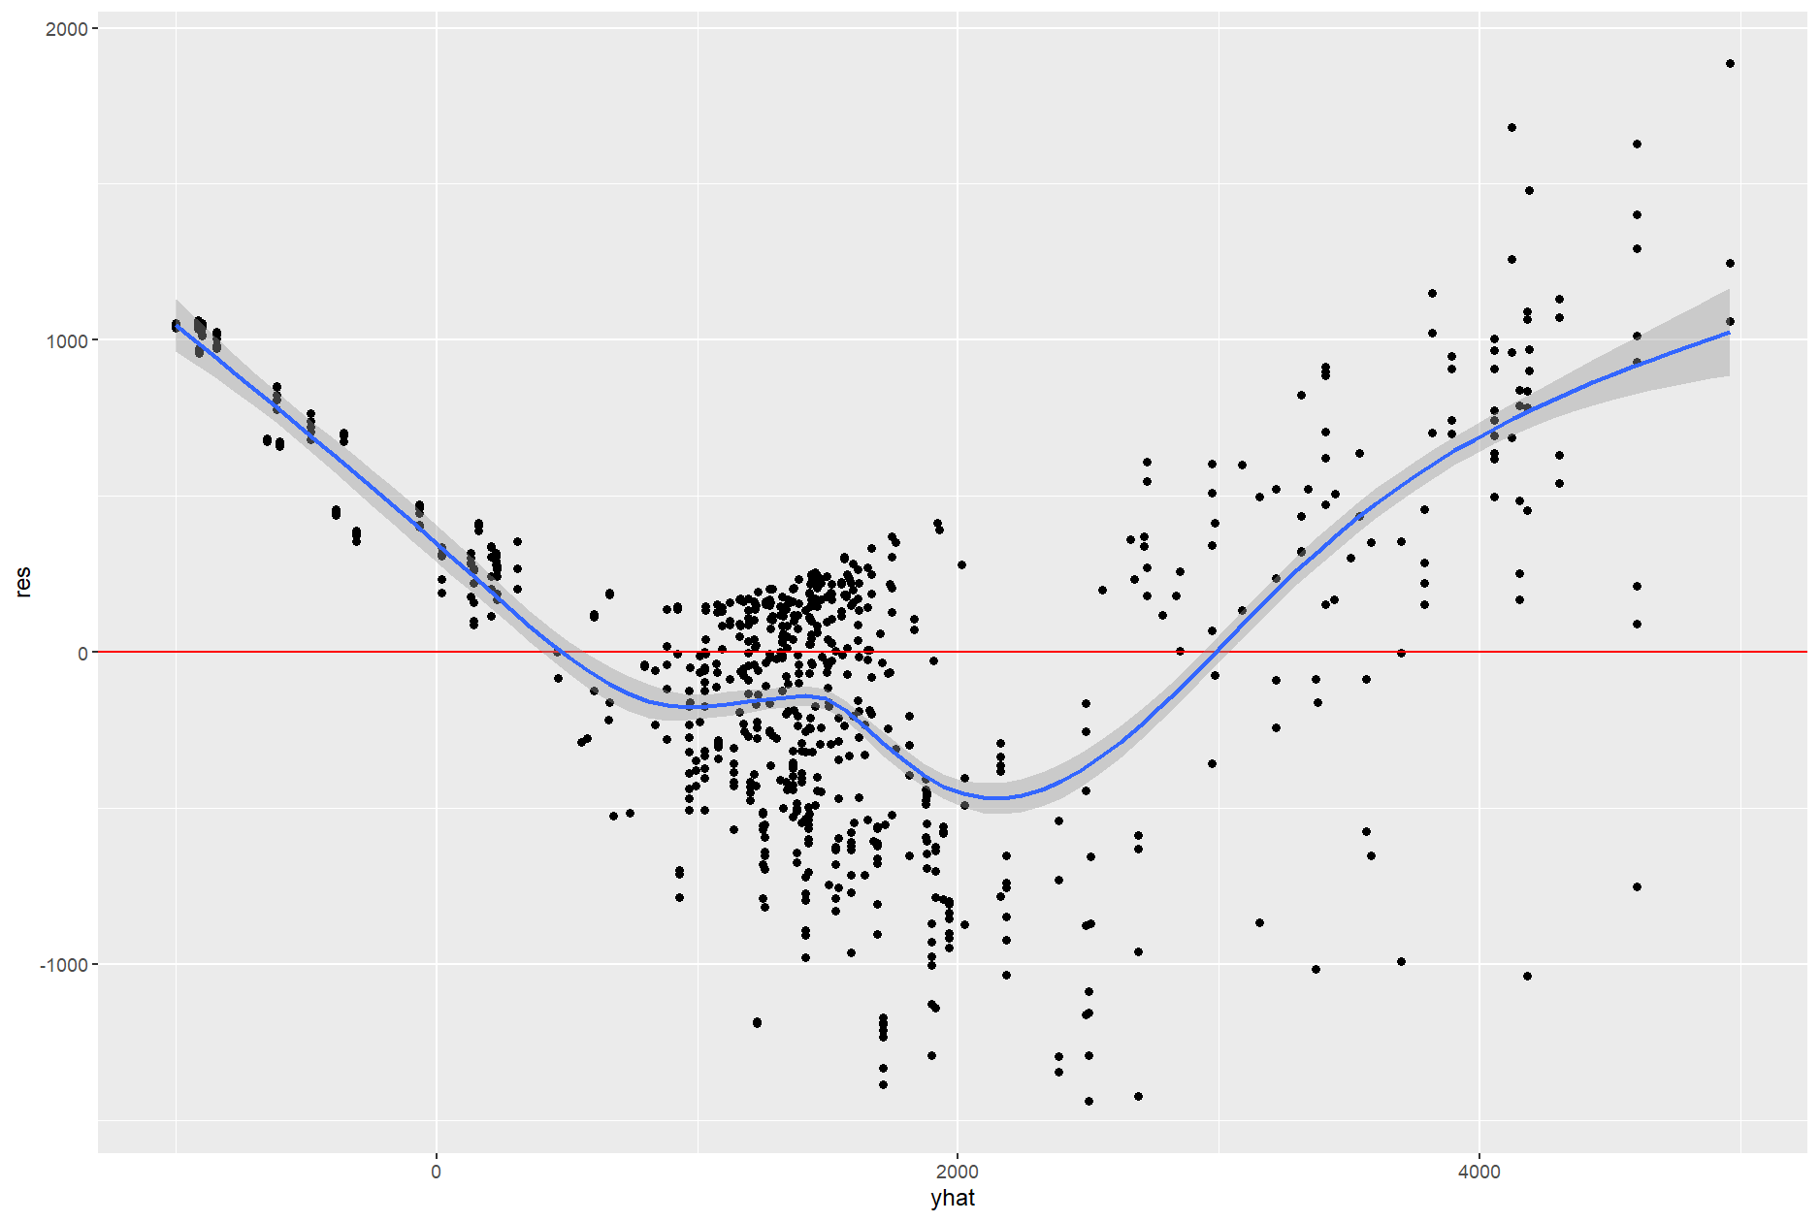

- A large discrepancy between residuals and actual values still occurs – suggesting that the residuals are not independent.

Improving the MLR model
I removed any outlier data points to improve the accuracy of the model and satisfy the main assumptions.
I removed loyalty point values >5000 to maintain model accuracy, while also capturing patterns.
I removed remuneration values >100 (outliers).
I fitted this model:
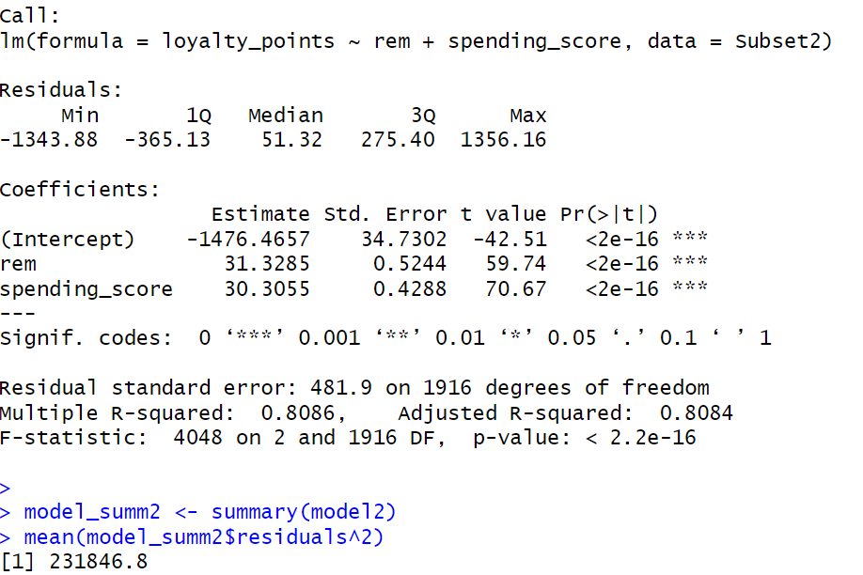
- The model is a strong fit on the data, as indicated by R-Squared, F-Statistic, and p-value.
- MSE still indicates significant prediction error, but a greater accuracy than using uncleaned data.

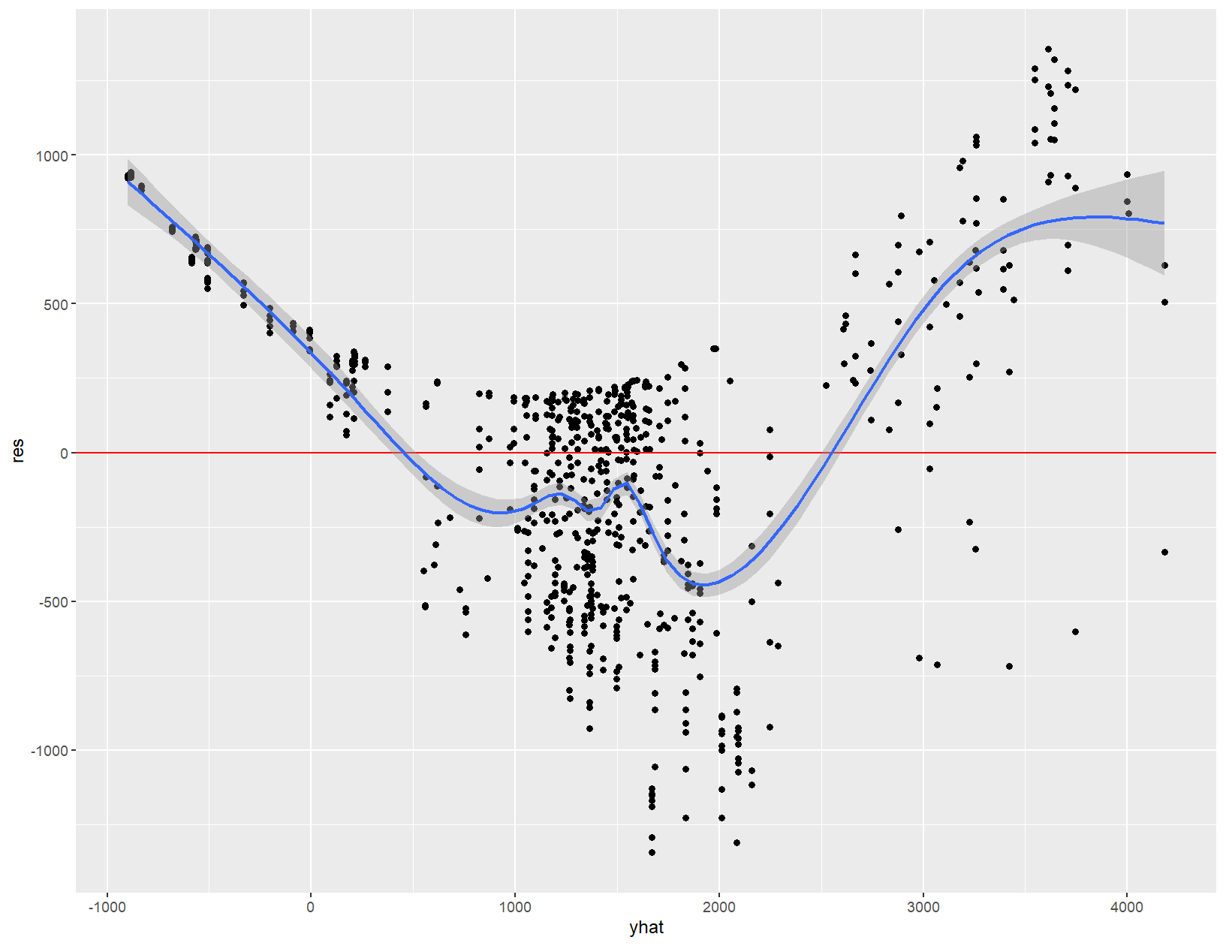

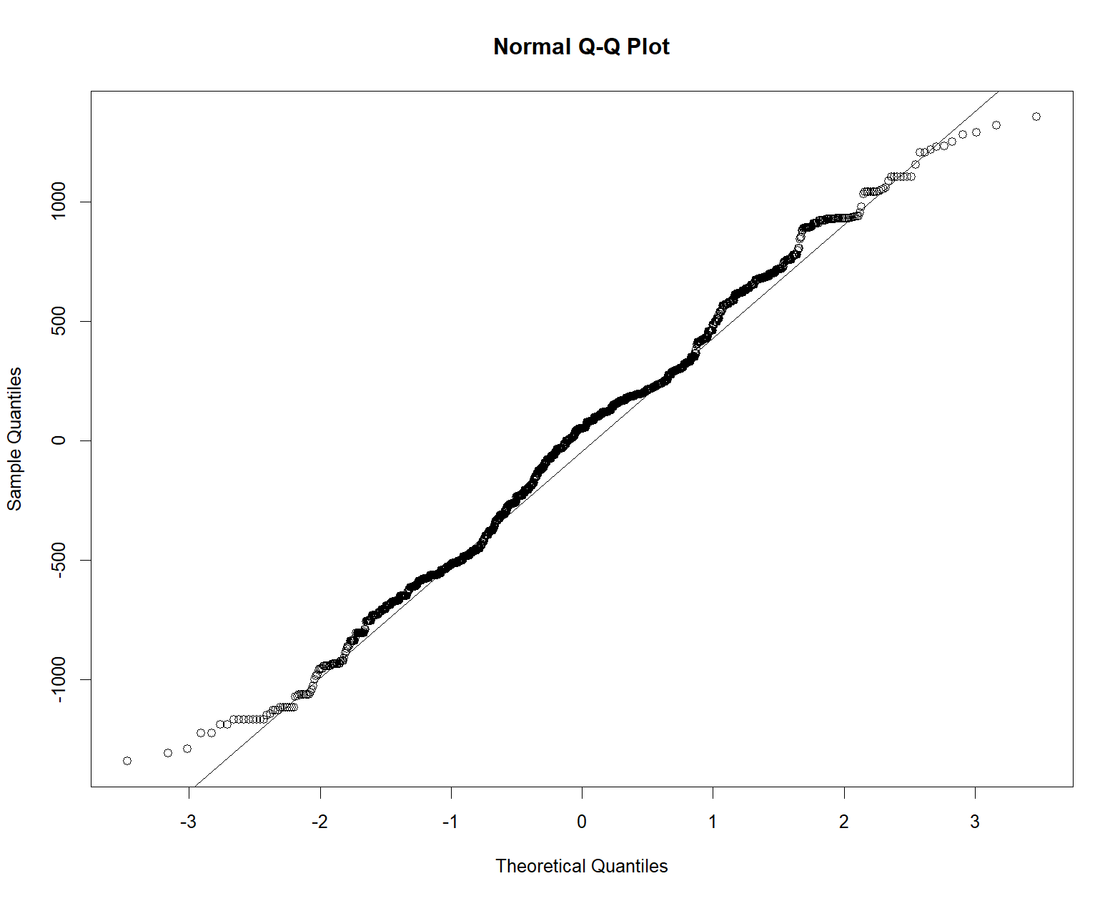
- The residuals are much closer to the fitted values, than in previous models. The model is more accurate in its predictive power.

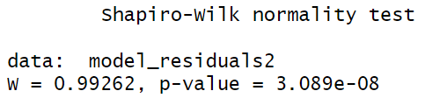

- The Q-Q Plot indicates a lower presence of outliers.
- Shapiro-Wilk Test p-value indicates that this model has a more normal distribution of residuals than the original MLR model, however, the distribution is still abnormal.

Removing residual outliers
I remove residual outliers to further improve my MLR model.
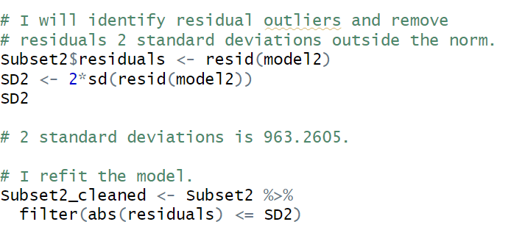
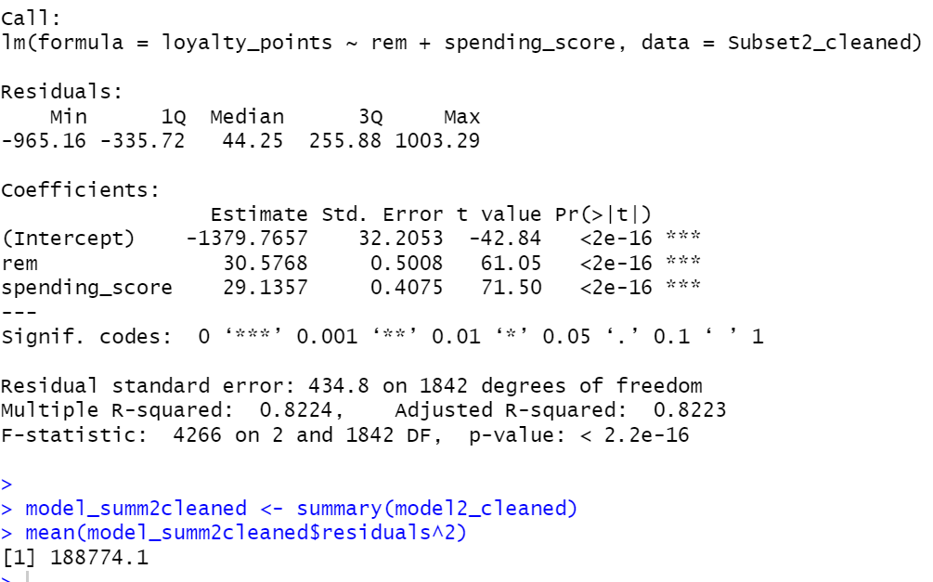
- R-Squared, F-Statistic, p-value indicate a strong fit.
- MSE is much lower than all previous models, however is still a significant prediction error.

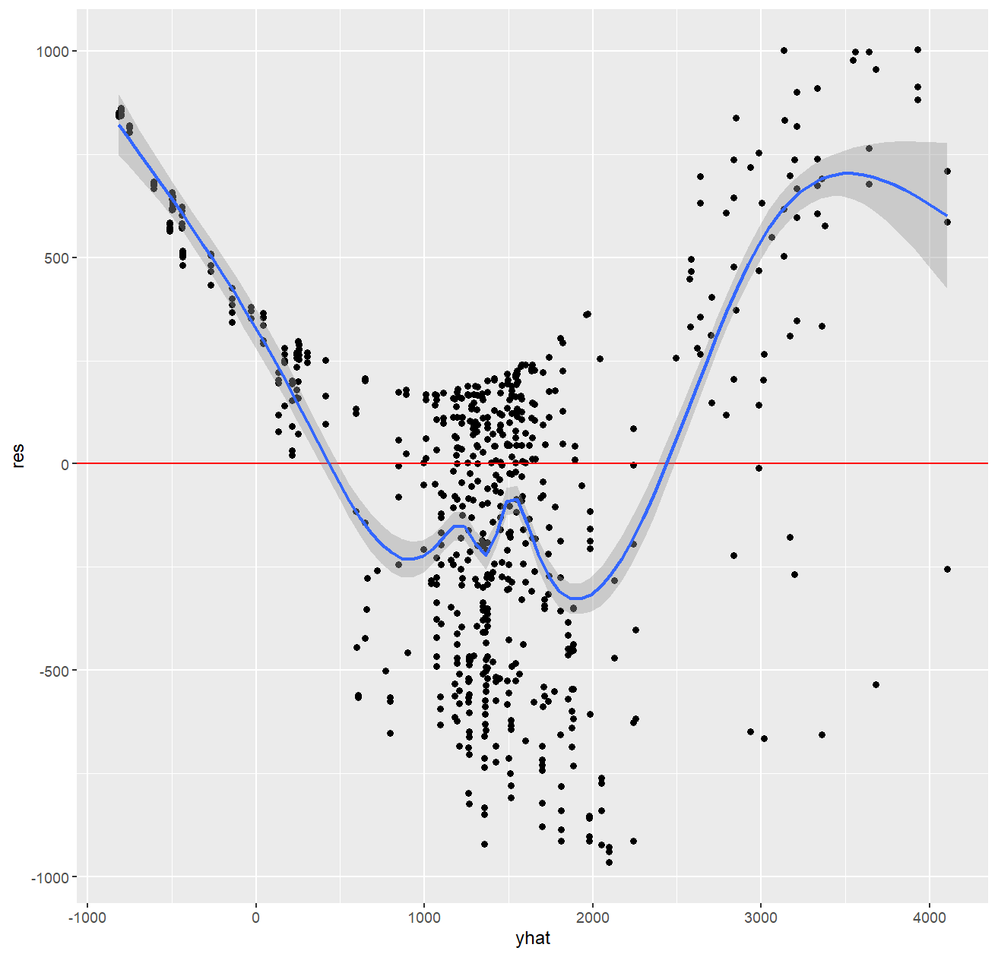

- Residuals are much closer to fitted values.
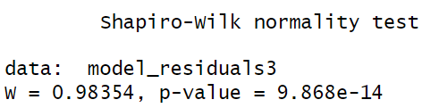
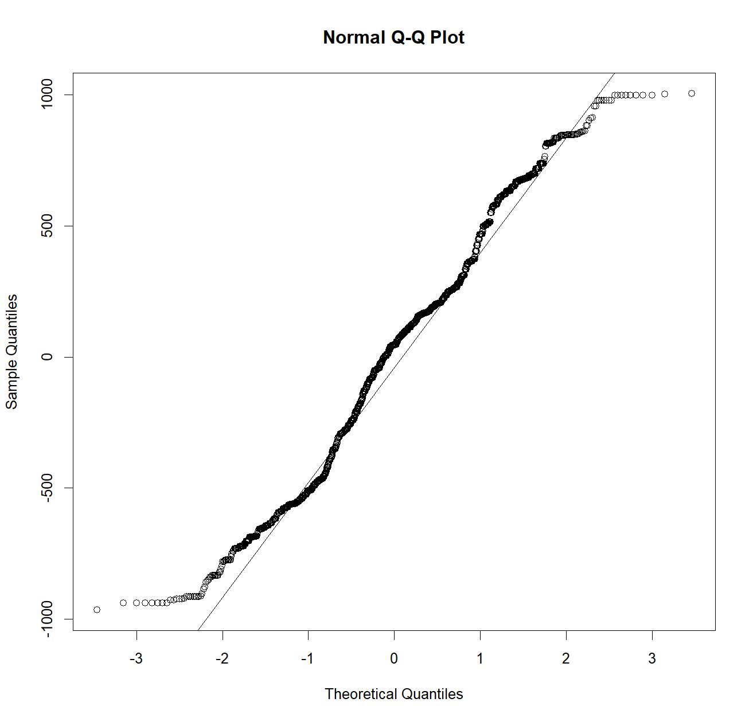

- However, the distribution of residuals is much more abnormal than with previous models.

While the normality of distribution is still greater than previously, since the model has a greater predictive accuracy, in the context of the investigation, I shall proceed with this model.

Visualizations
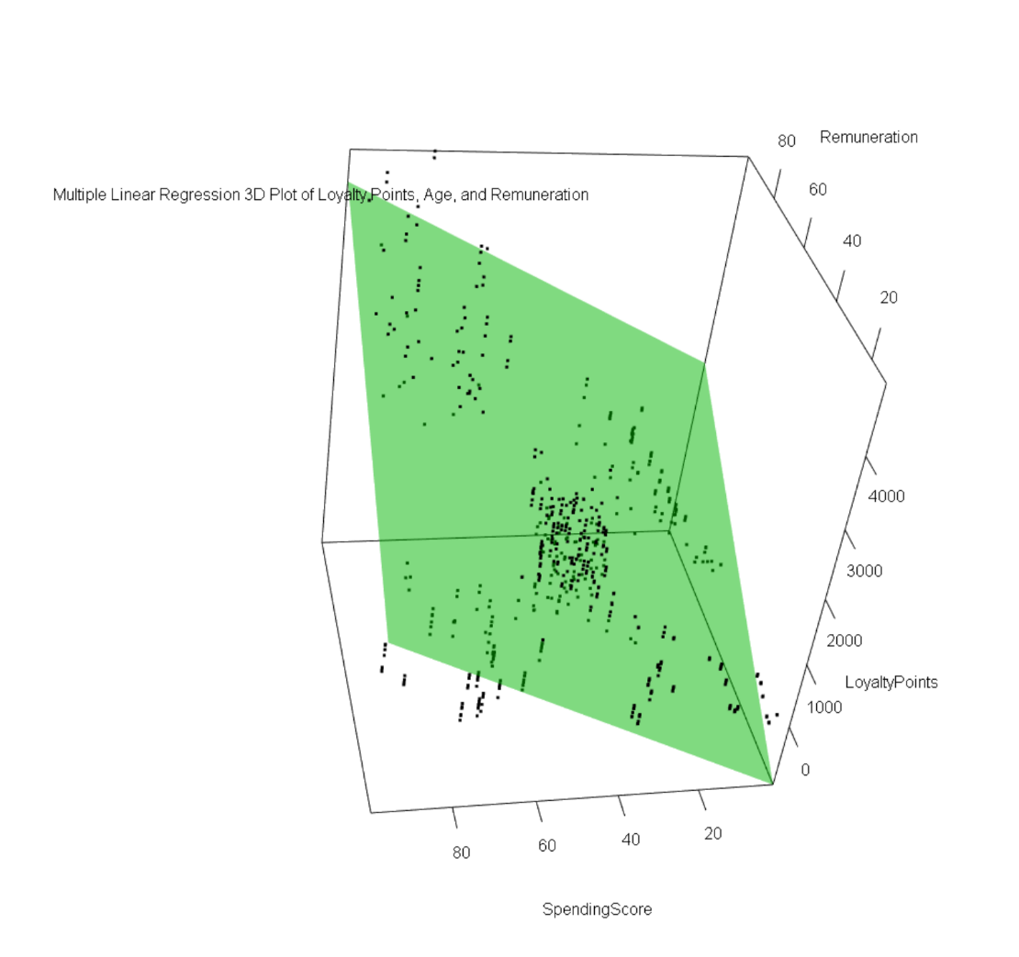

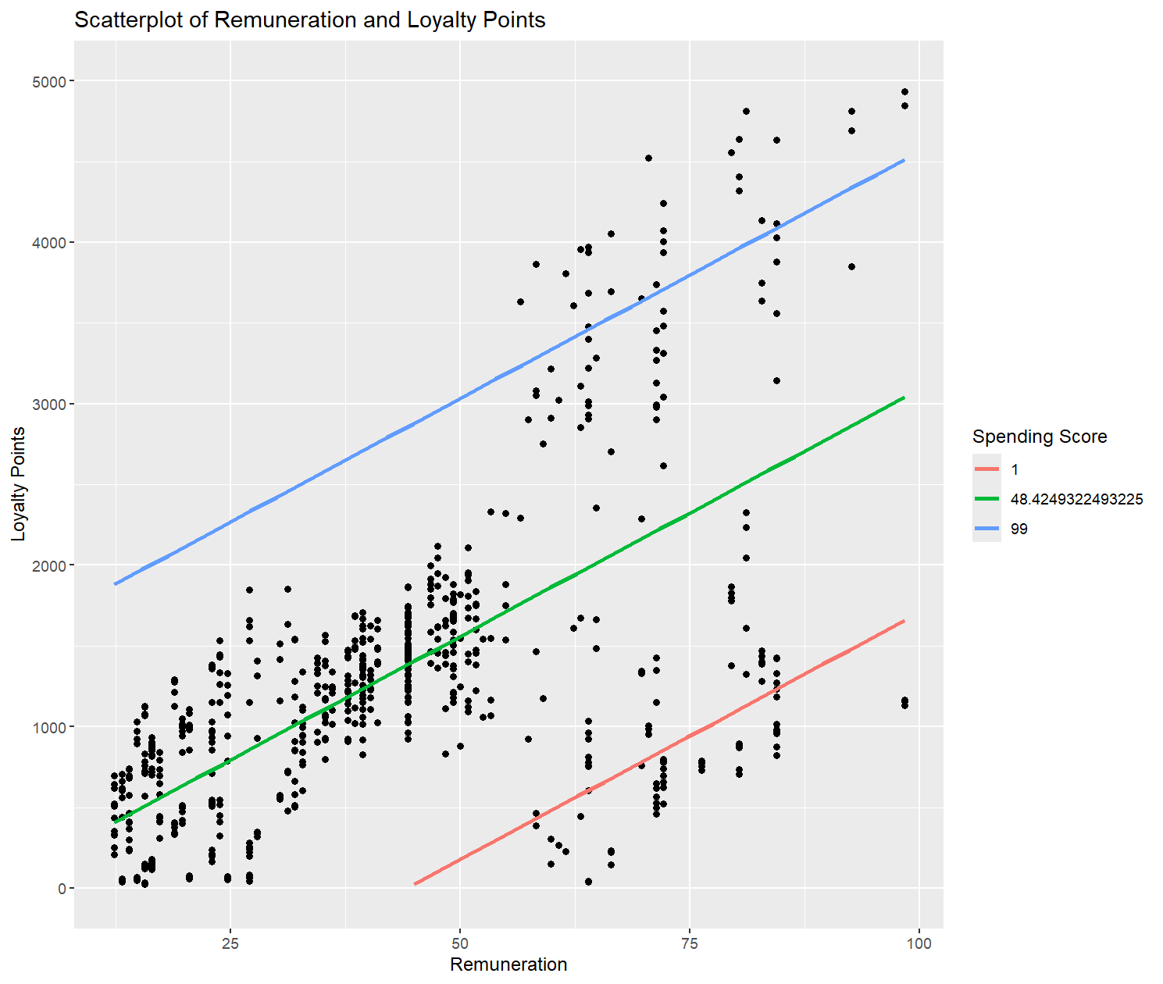

- We can see that as remuneration and spending score are both linked to greater loyalty point accumulation.
- Two distinct sub-populations exist:
  - High remuneration, and low spending score, and loyalty points.
  - High spending score, but low remuneration, and loyalty points.

Summary
- An MLR model was produced that captures much of the underlying patterns. The compromise of this however was the presence of abnormal residual distribution, indicating that the model is not entirely accurate.
- The patterns confirm that remuneration, spending score, and loyalty points are positively correlated with each other.

Q5
I created a binary logistic regression model to predict if customers are high earners (>2000 loyalty points).
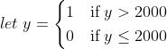
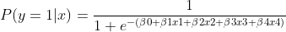

I made an initial model:
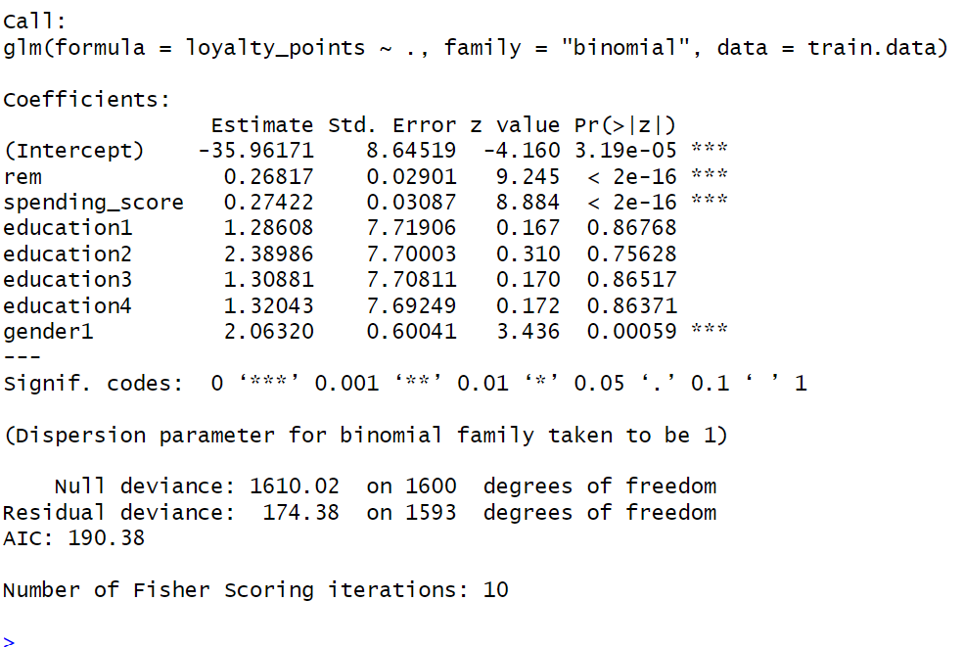
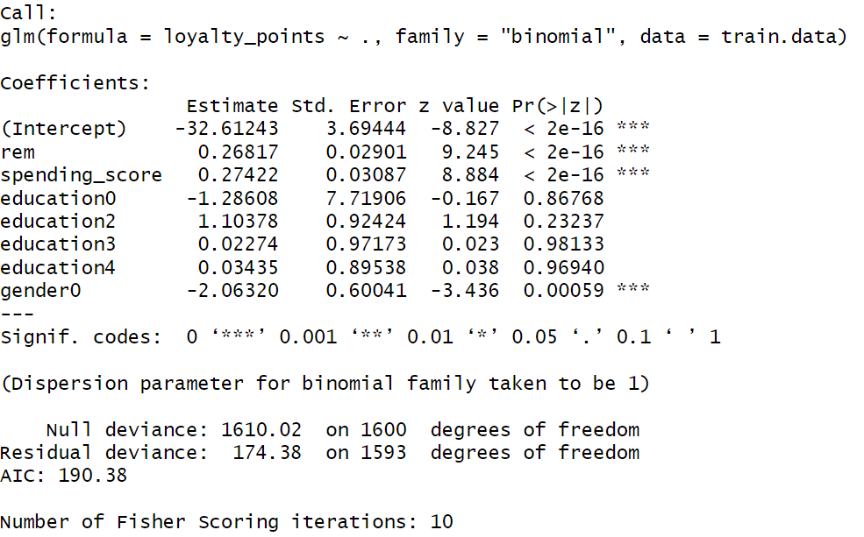

- From this, I found that remuneration, spending score, and gender are significant in predicting my outcome variable.

I split my dataset into training and test sets. I then predicted the probability of y=1 for each observation in the test set.
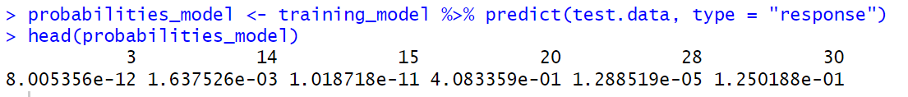
I rounded each predicted value to either 1 or 0.

Accuracy testing
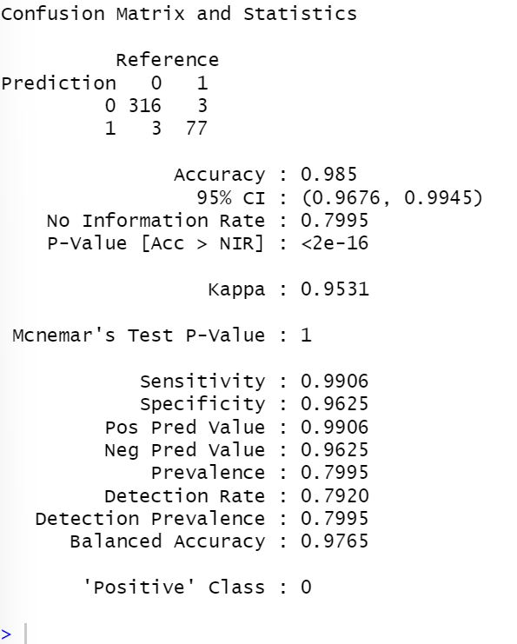
- The model is highly accurate, predicting true positives and true negatives 98.5% correctly.
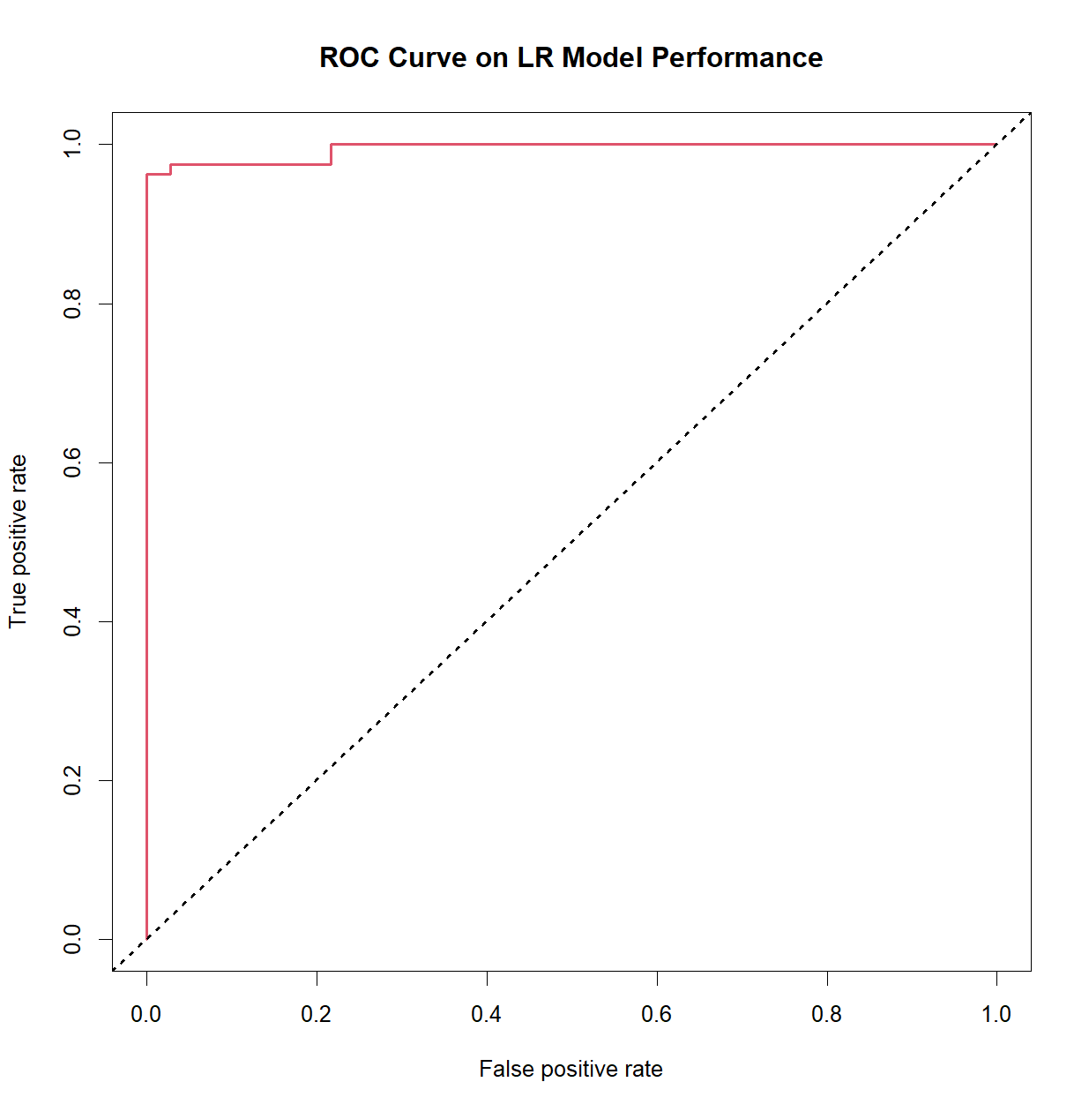

- ROC Curve and AUC value indicate near perfect predictive accuracy.

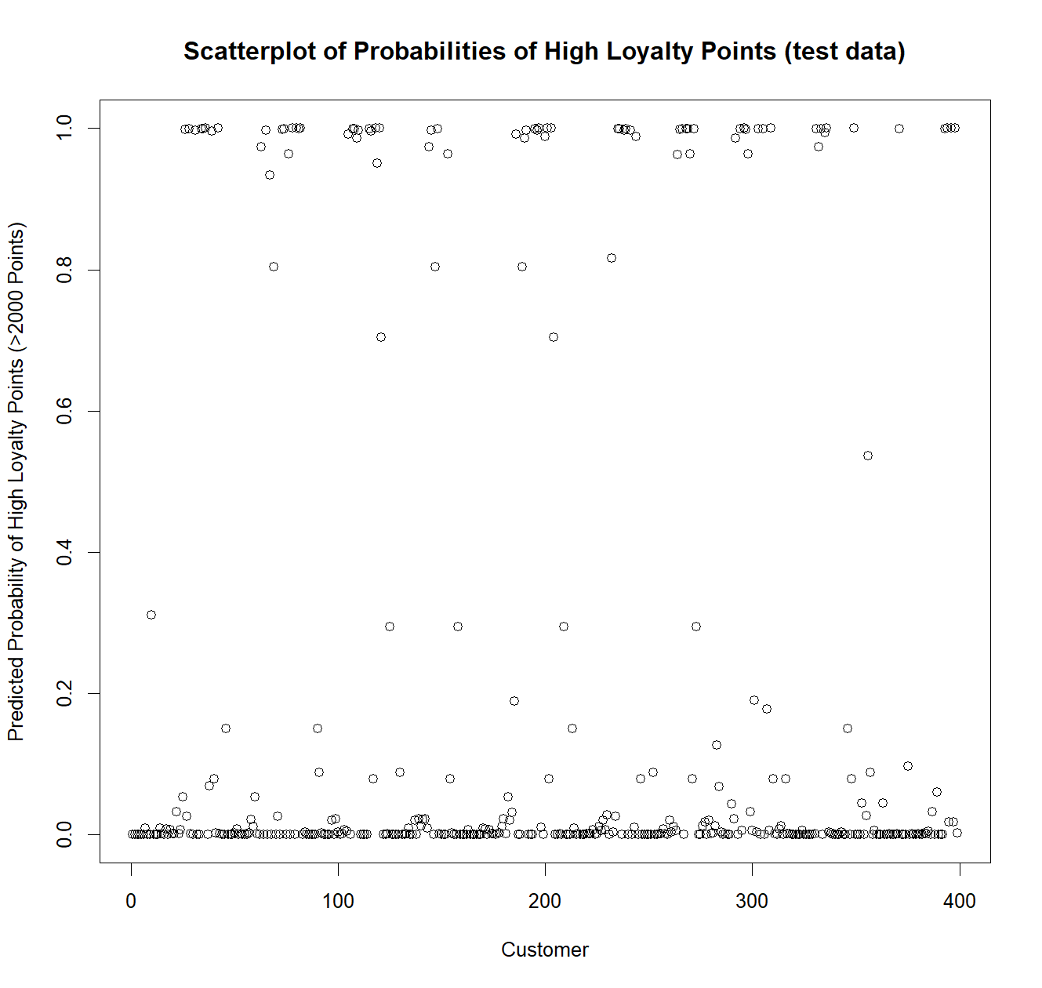
Visualizations

- The model predicts most customers to be low loyalty point customers.
- This is corroborated by the actual raw data, which supports this.
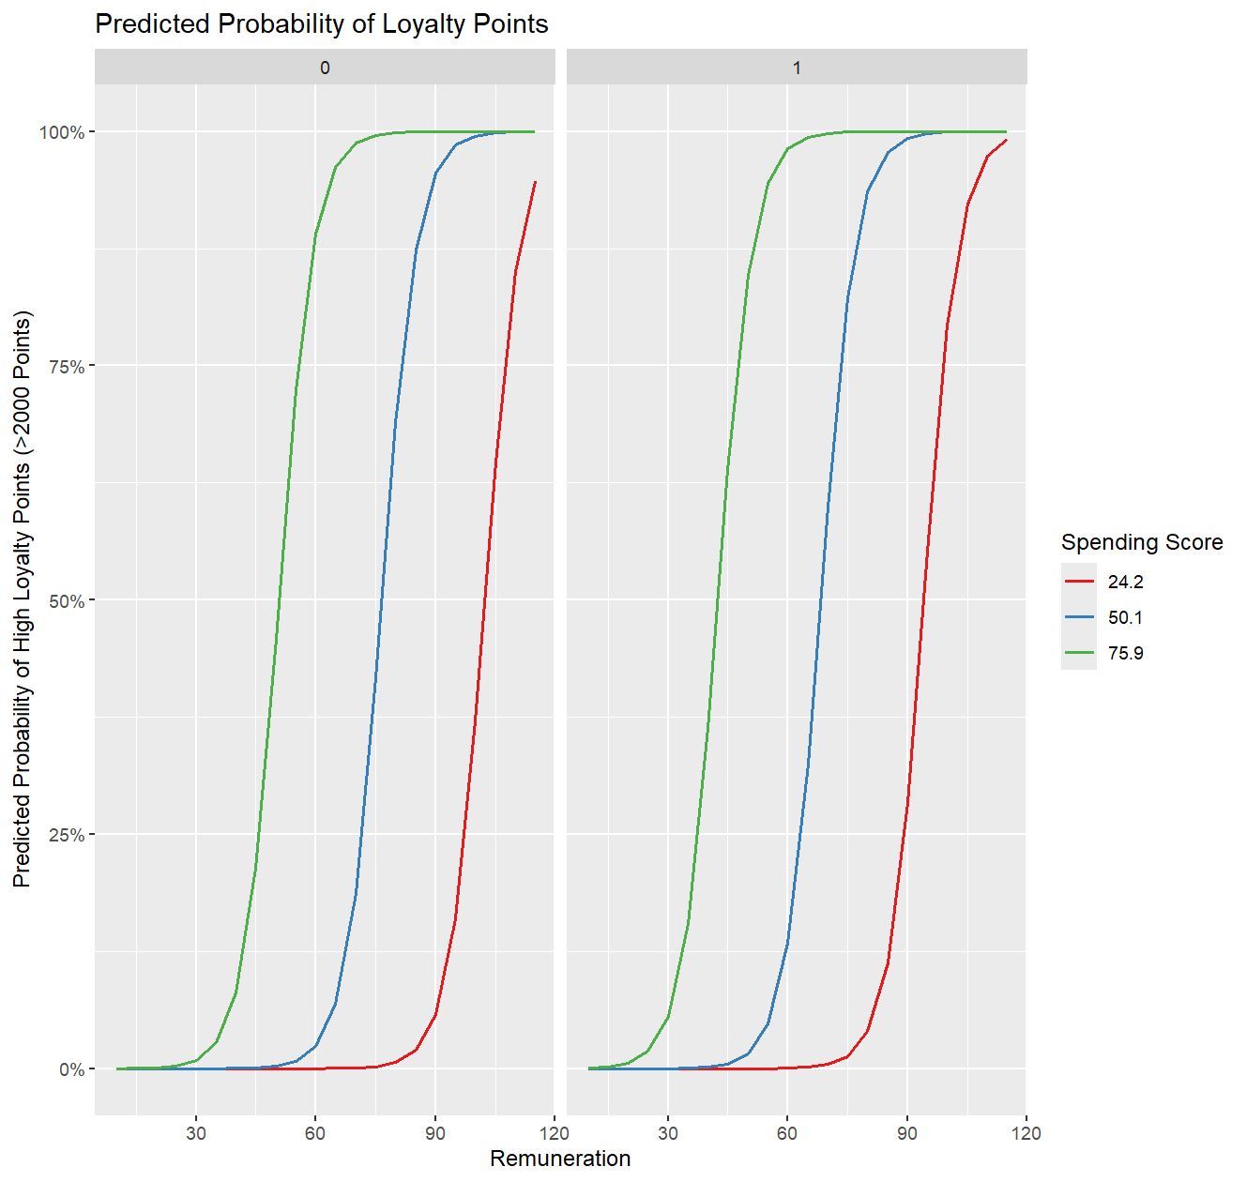
Males = ‘0’
Females = ‘1’

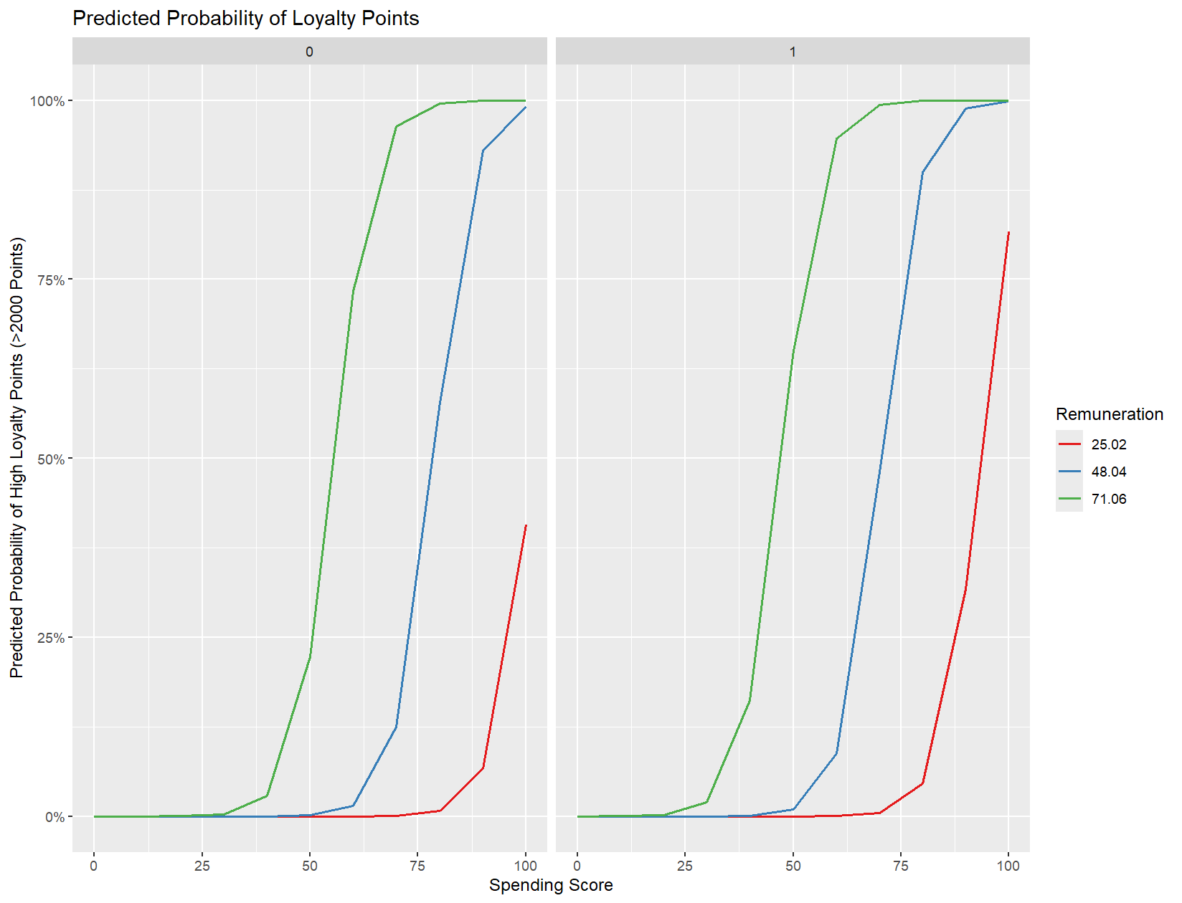

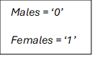

- For both males and females, greater remuneration is associated with a higher probability of being a high point customer. This probability is compounded by a higher spending score.
- However, when comparing males and females with similar spending scores, females are more likely to be high point customers. Males with high spending score and low remuneration are unlikely to be high point customers.
  - This group of males who behave in this trend may be those who comprise this cluster of high spending score, but low remuneration, and loyalty point values.

Summary
- Logistic regression model proved to be highly accurate.
- Granular insights were derived into customer trends by remuneration, spending score, and gender, in relation to loyalty points.

Q6
I explore the overall sentiment of the reviews and products left by the customers.
I explored the data within two variables – ‘reviews’ and ‘summary’.

Top 15 words
I found the top 15 most common words in both sets.
I normalised my data, by removing stopwords, and lemmatizing words, in order to produce only the top 15 most common meaningful words.

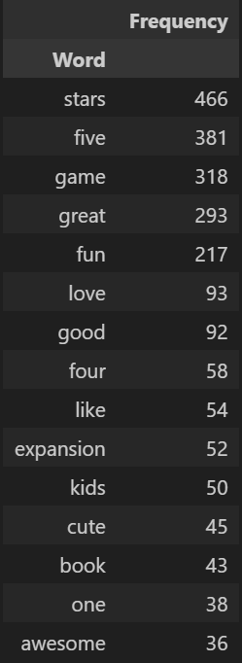

‘reviews’
‘products’

- We see generally that the most frequent words in both sets are very positive. Customers generally enjoy the product.
‘reviews’
- ‘game’, however, is the most frequent word, which is quite neutral, however most other words are positive.

However, it would provide more insight to look into more granularity. Word frequency does not paint a full picture. For example, one of the most popular words in both sets is ‘one’ – this is ambiguous (‘One Star’, or ‘One of my favourite games’?)

Review sentiment
I analysed the reviews using VADER Sentiment Analysis. Because VADER analyses sentiment by also considering caps and punctuation, I did not alter these. However, many of reviews were hidden behind HTML links, which I pre-processed, applying a user-defined function.
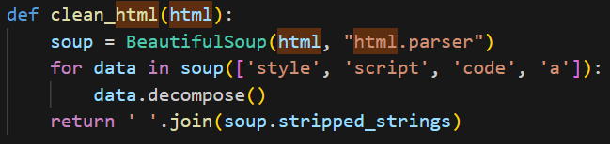
For each review, I found the compound polarity score (ranging from -1 (extremely negative) to +1 (extremely positive)).
20 Most Positive Reviews

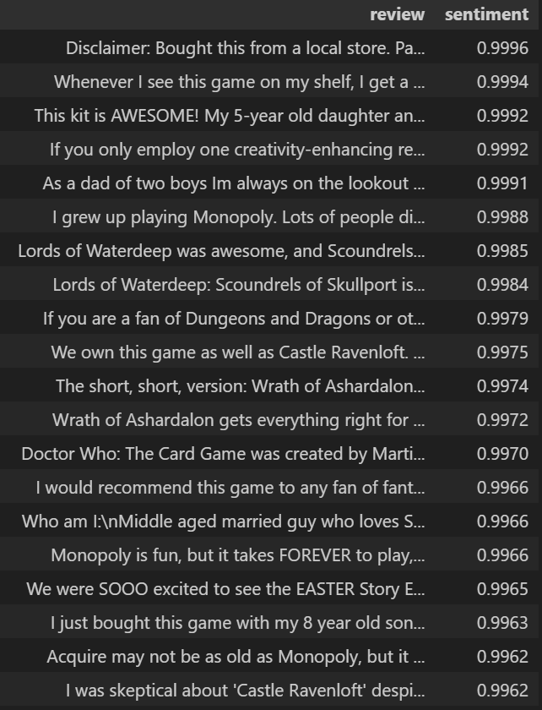

20 Most Negative Reviews


- It is tedious to examine each review. It may be inaccurate for a person to analyse each review in these subsets to find the commonalities between positive and negative reviews.
- The ‘summary’ set may be easier to derive sentiment patterns.

I visualized the distribution of overall review sentiment.
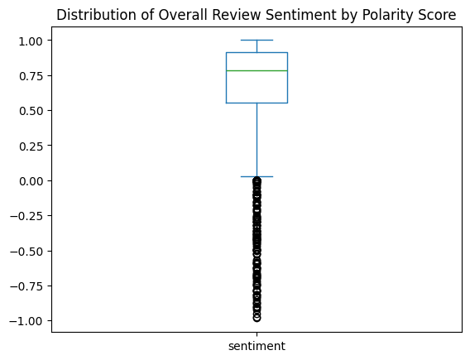
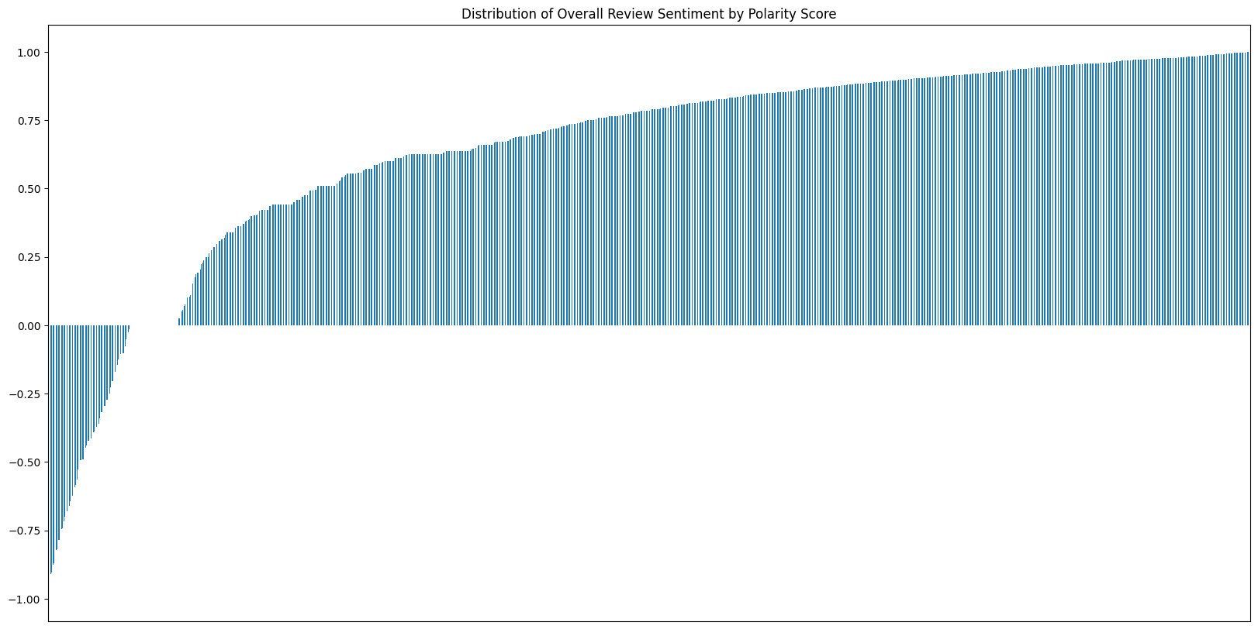
- A more obvious pattern emerges here: Most reviews are highly positive – however, a significant contingent is very negative.

Summary sentiment
In analysing the ‘summary’ sentiments, I encountered a problem. Many of the rows contained summaries such as ‘One Star’ or ‘Five Star’, however, VADER calculated the compound polarity of such summaries as 0.0.
To solve this problem, I added appropriate weighting to certain strings, then updated the SentimentIntensityAnalyzer lexicon.
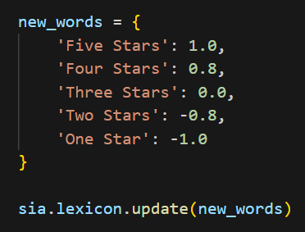
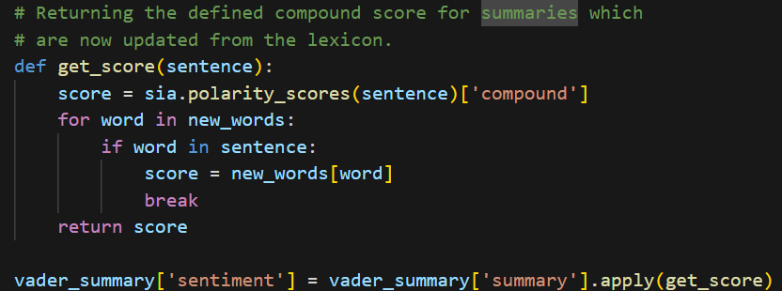

However, this resulted in a case where the top 20 positive and negative summaries were ‘Five Stars’ and ‘One Star’ respectively.
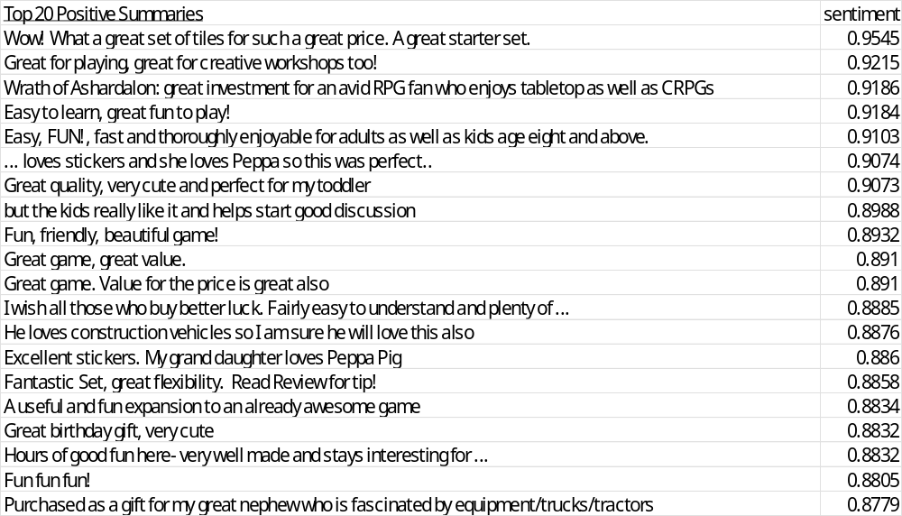
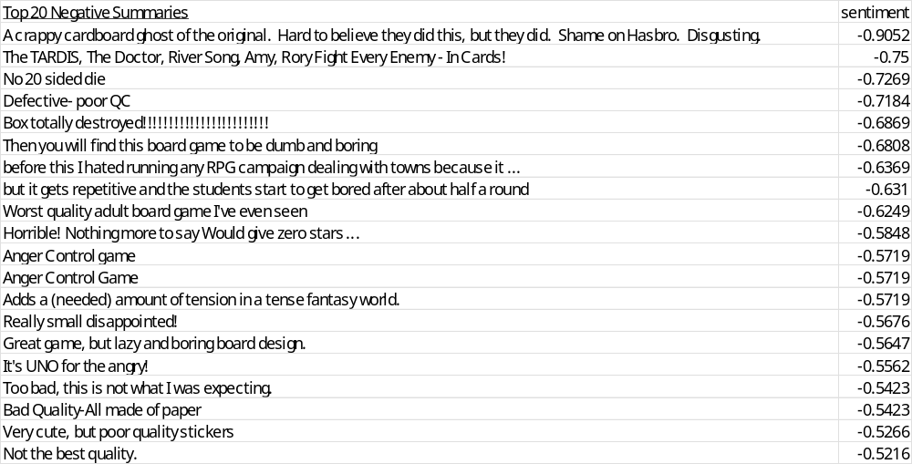

- The positive summaries were high in polarity, indicating that the game is fun, of great value, intuitive for children, and engaging.
- The negative summaries were not as extreme in their negative polarity as compared to the positive summaries. The negative summaries highlighted mostly frustration arising from the game, and quality issues with the equipment.

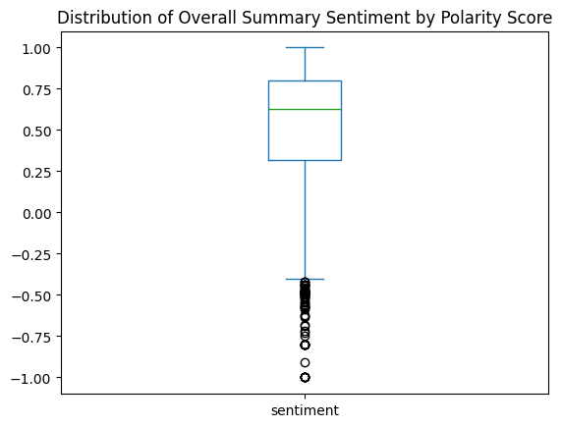
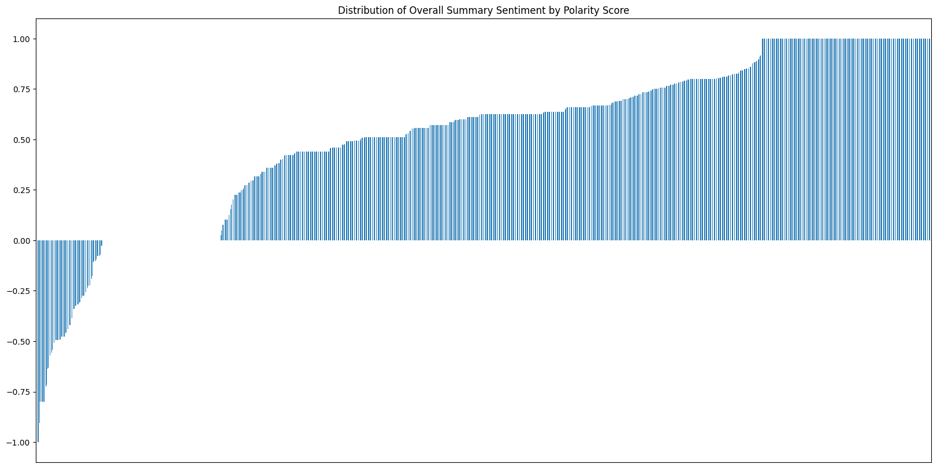

- The trend in summary polarity score distribution mirrored that of reviews.
- However, a larger contingent were entirely neutral, perhaps due me updating the compound polarity of ‘Three Stars’ to 0.0.

Summary
- The ‘summary’ set provided a clearer insight into customer sentiments.
- The product is generally positive among the customers, however, significant number report issues concerning equipment quality and frustration.

